1. DRRM COMPLIANCE SYSTEM (GENERAL)

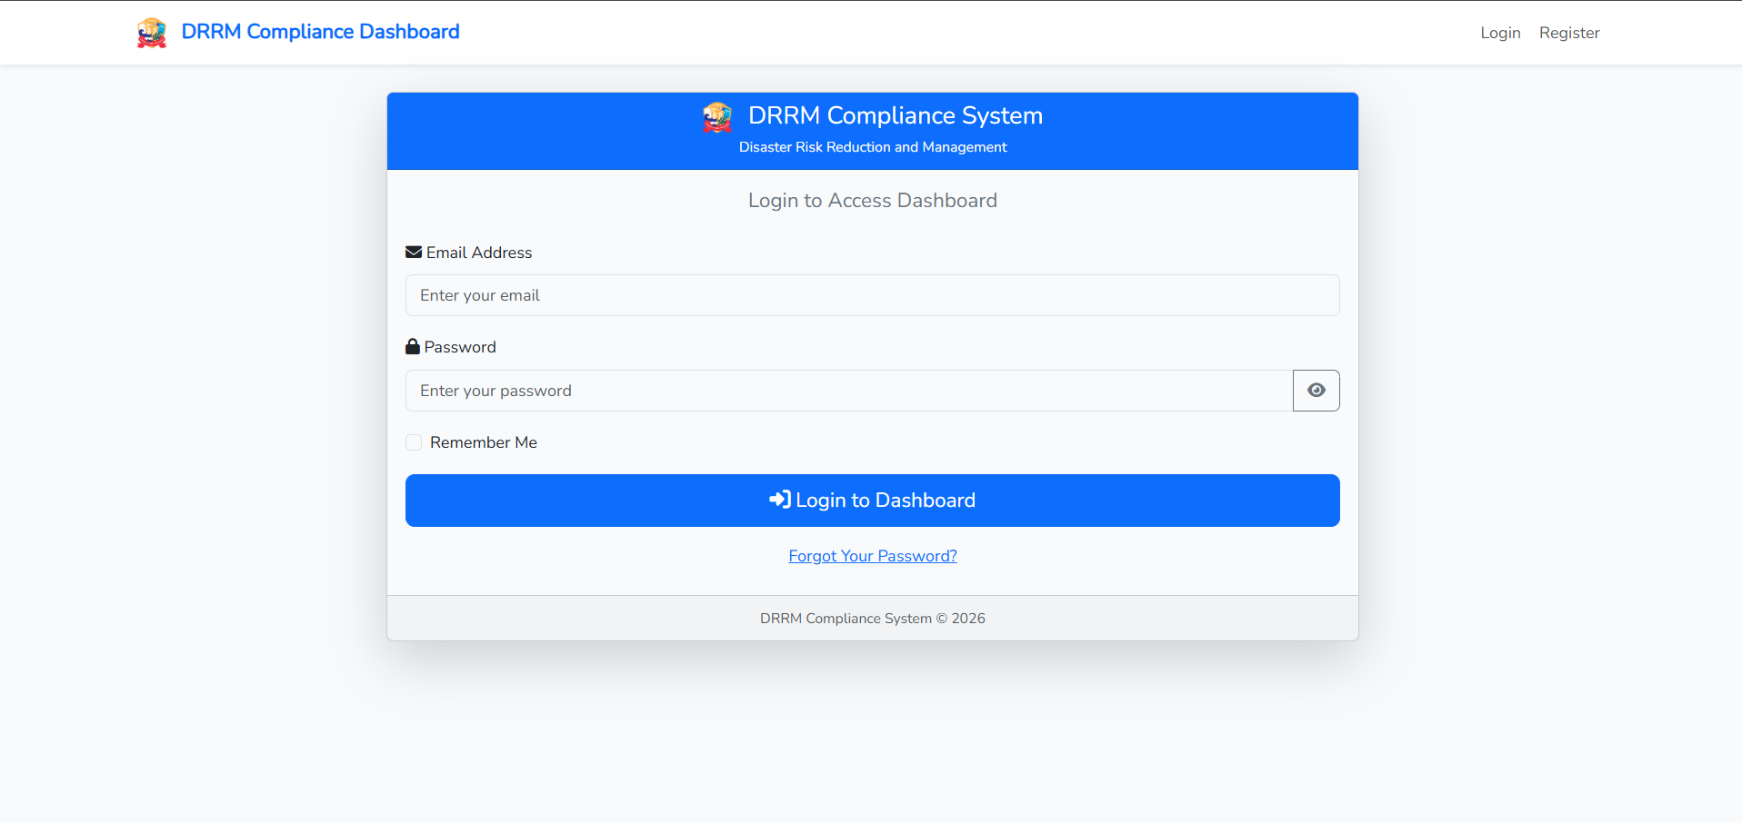
1.1 Login Page
The entry point of the system where users authenticate their identity to access school safety data.
- Access the system via the provided URL.
- Log in using your email and password.
- Roles: Admin (Full access), Contributor (School-specific), Viewer (Read-only).

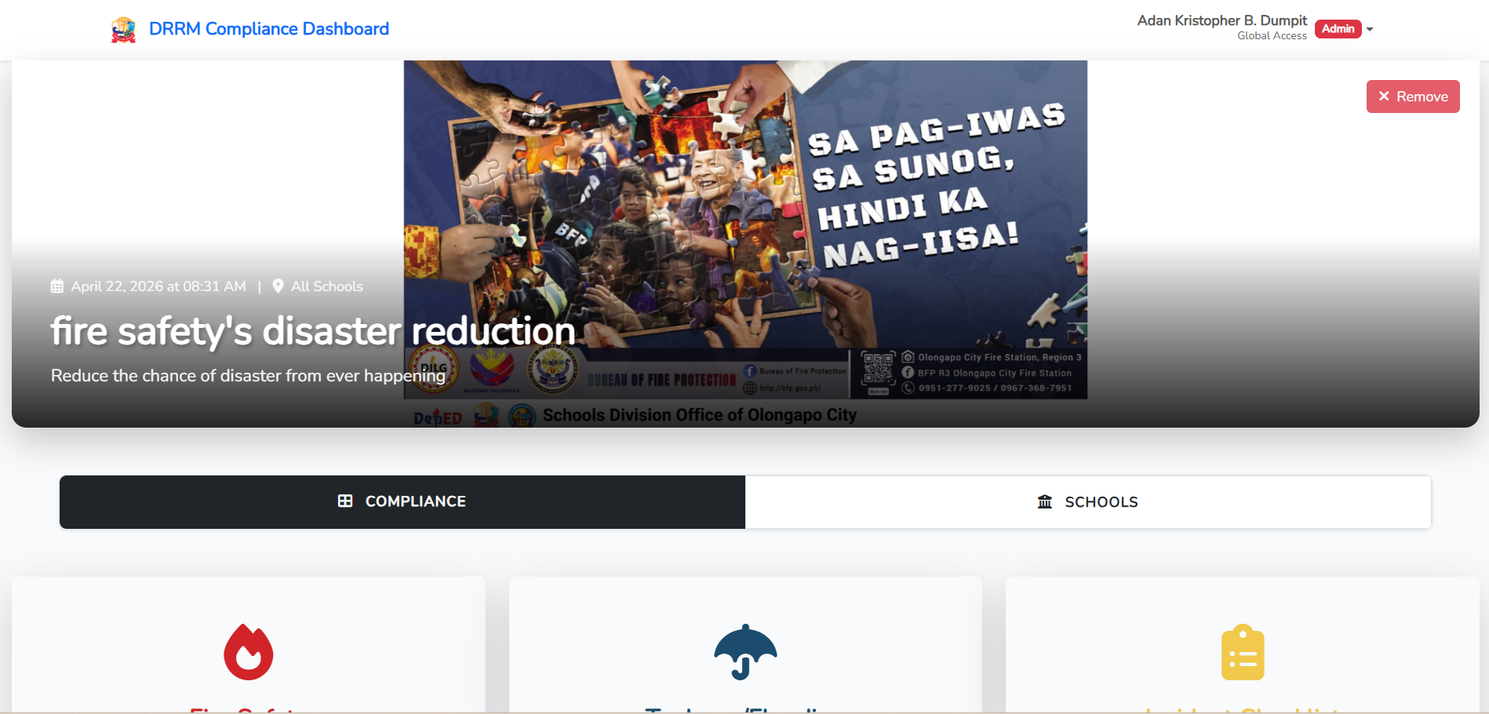
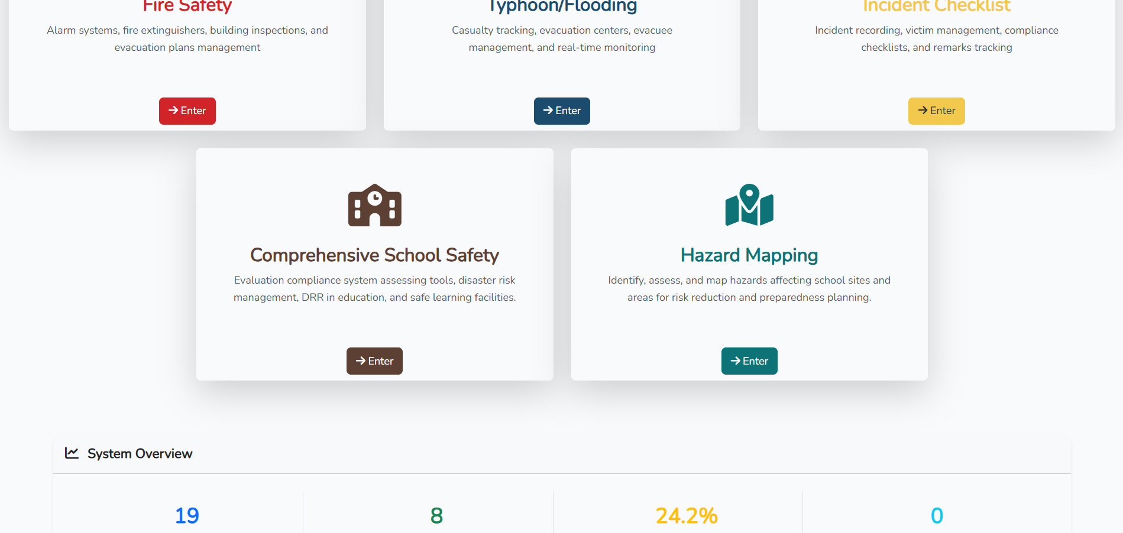

1.2 DRRM Compliance Main Dashboard - Compliance Tab
A high-level overview of the entire DRRM system, showing compliance statuses across all modules.
- Central hub for all safety modules.
- Click on any module card (Fire Safety, Typhoon/Flood, Incident Checklist, CSS) to enter.
- Displays high-level compliance percentages for the selected school.

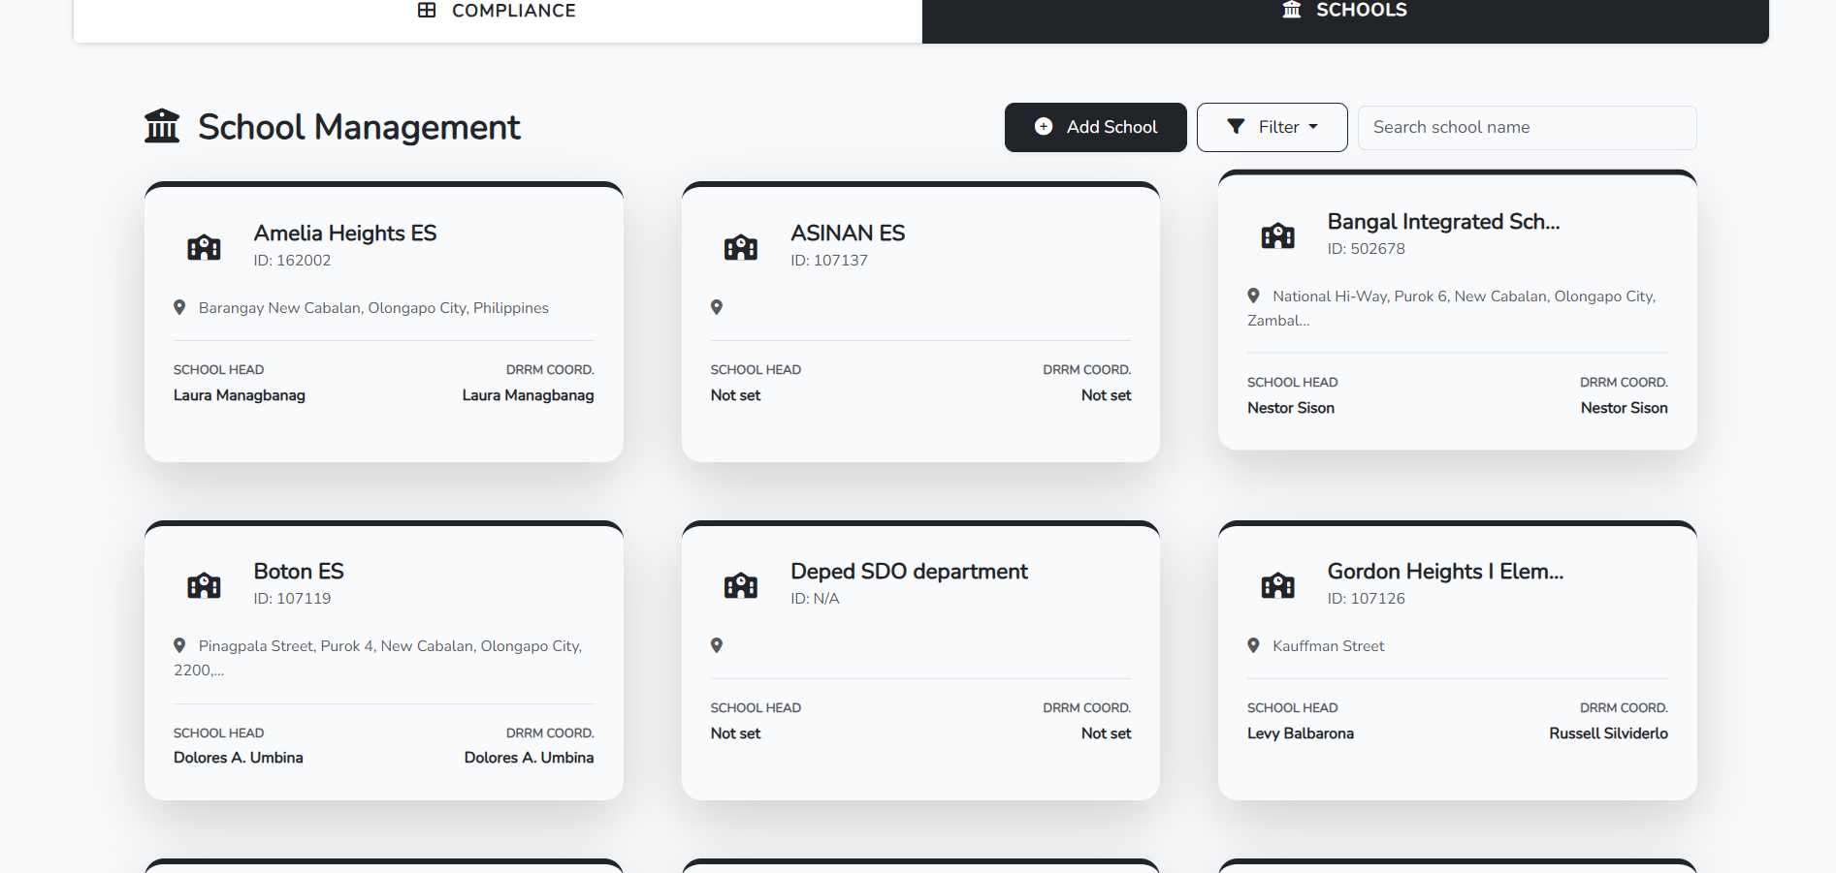
1.3 DRRM Compliance Main Dashboard - Schools Tab
A directory of schools within the division, allowing admins to manage school data and view specific school profiles.
- Admin: Manage all schools, view school IDs, and overall statuses.
- Contributor: View assigned school details.
- Search bar: Find schools by name or ID.

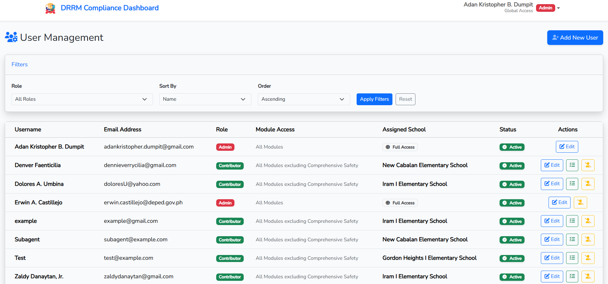
1.4 User Page
Centralized user management for controlling system access, adding new staff, and assigning roles/schools.
- Manage accounts and roles.
- Admins can add new users and assign them to specific schools.
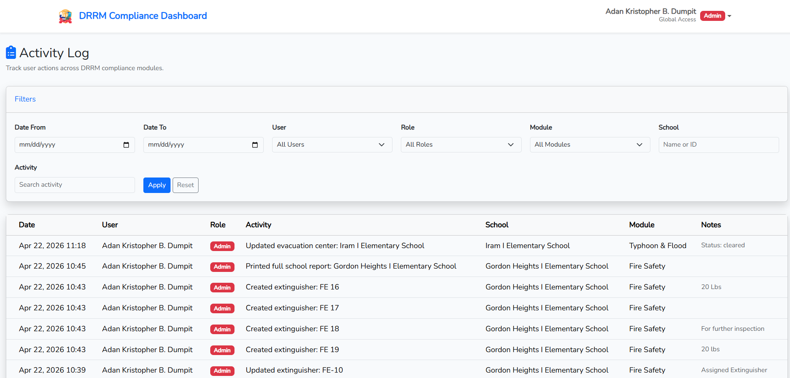
1.5 Activity Log
A transparency tool that tracks all administrative actions to maintain accountability within the system.
- Audit trail for all system changes.
- Records who, what, and when.
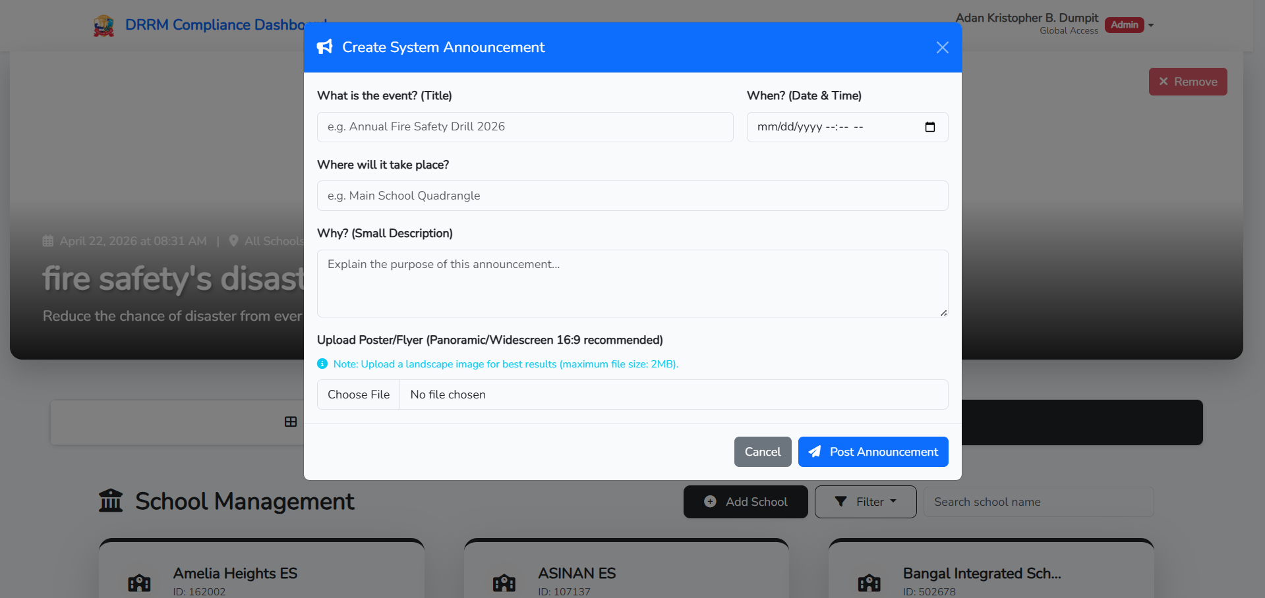
1.6 Create System Announcement Modal
A tool for broadcasting critical updates or emergency notifications to all users in the system.
- Click the Announce button at the profile bar to broadcast messages.
- Enter a title and content to inform all users about system updates or emergencies.

Fire Safety Compliance System
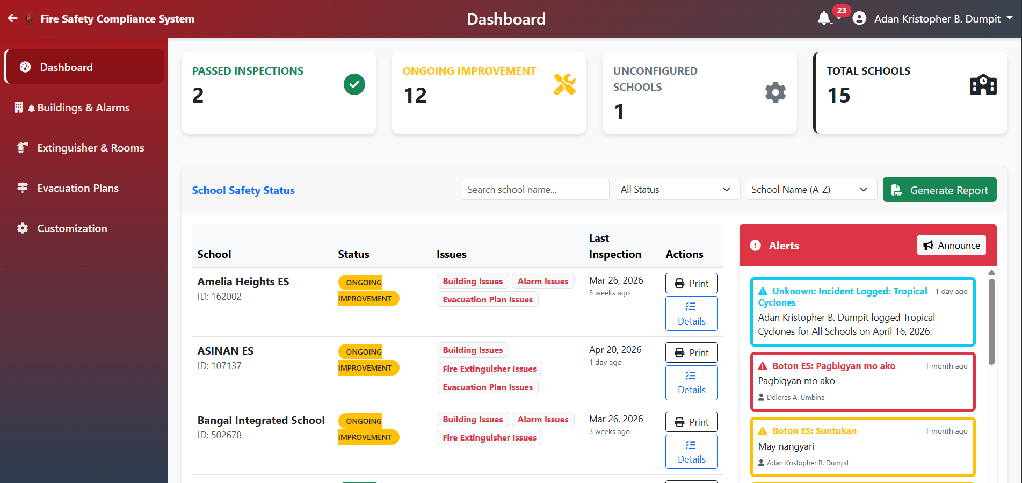
2.1 Dashboard Page
A management console for monitoring fire safety compliance across all schools in the division.
Division Cards::
- Passed Inspections: Schools that are 100% compliant.
- Ongoing Improvement: Schools with active safety issues.
- Unconfigured: Schools waiting for initial setup.
- Total Schools: Overall count in the division.
Buttons:
- Generate Report: Download a division-wide summary.
- Print/Success: Actions for individual schools to view or print details.

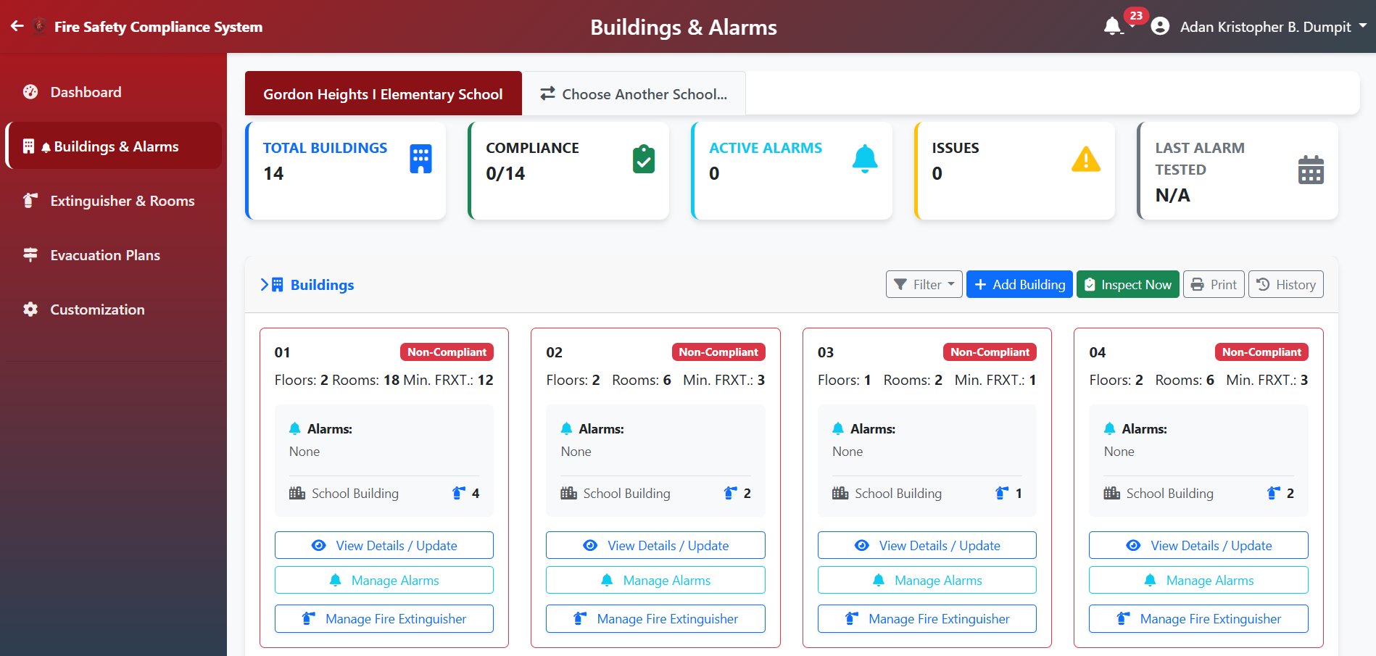
2.2 Building Page
Detailed management of school structures, including floor levels, room counts, and safety feature tracking.
Buttons:
Add Building - Click "Add Building", enter code, floors, and rooms.
Update Building - Click "View Details / Update" to change info or add safety features.
Manage Alarm - Clicks “Manage Alarms” to display a modal allowing user to add alarms and update existing ones
Manage Fire Extinguisher- Displays the breakdown of rooms & extinguisher created for that building.
History view removed buildings, floors or rooms.
Inspection: "Inspect Now" records drills and checklist results.

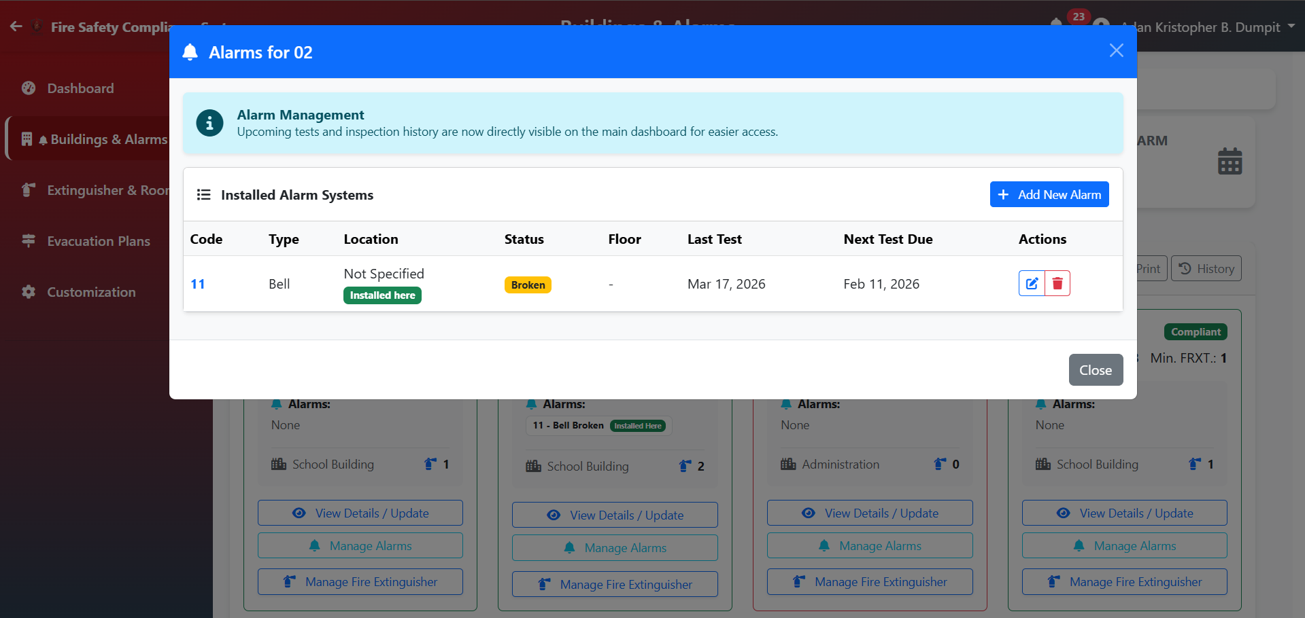
2.3 Alarm Management
Tracks the installation, functionality, and maintenance schedule of fire alarm systems across the campus.
- Add Alarm: Specify code, type, and buildings covered.
- Update Alarm: Mark as functional or needs maintenance.
- Record Test: Set the last test date for maintenance tracking.
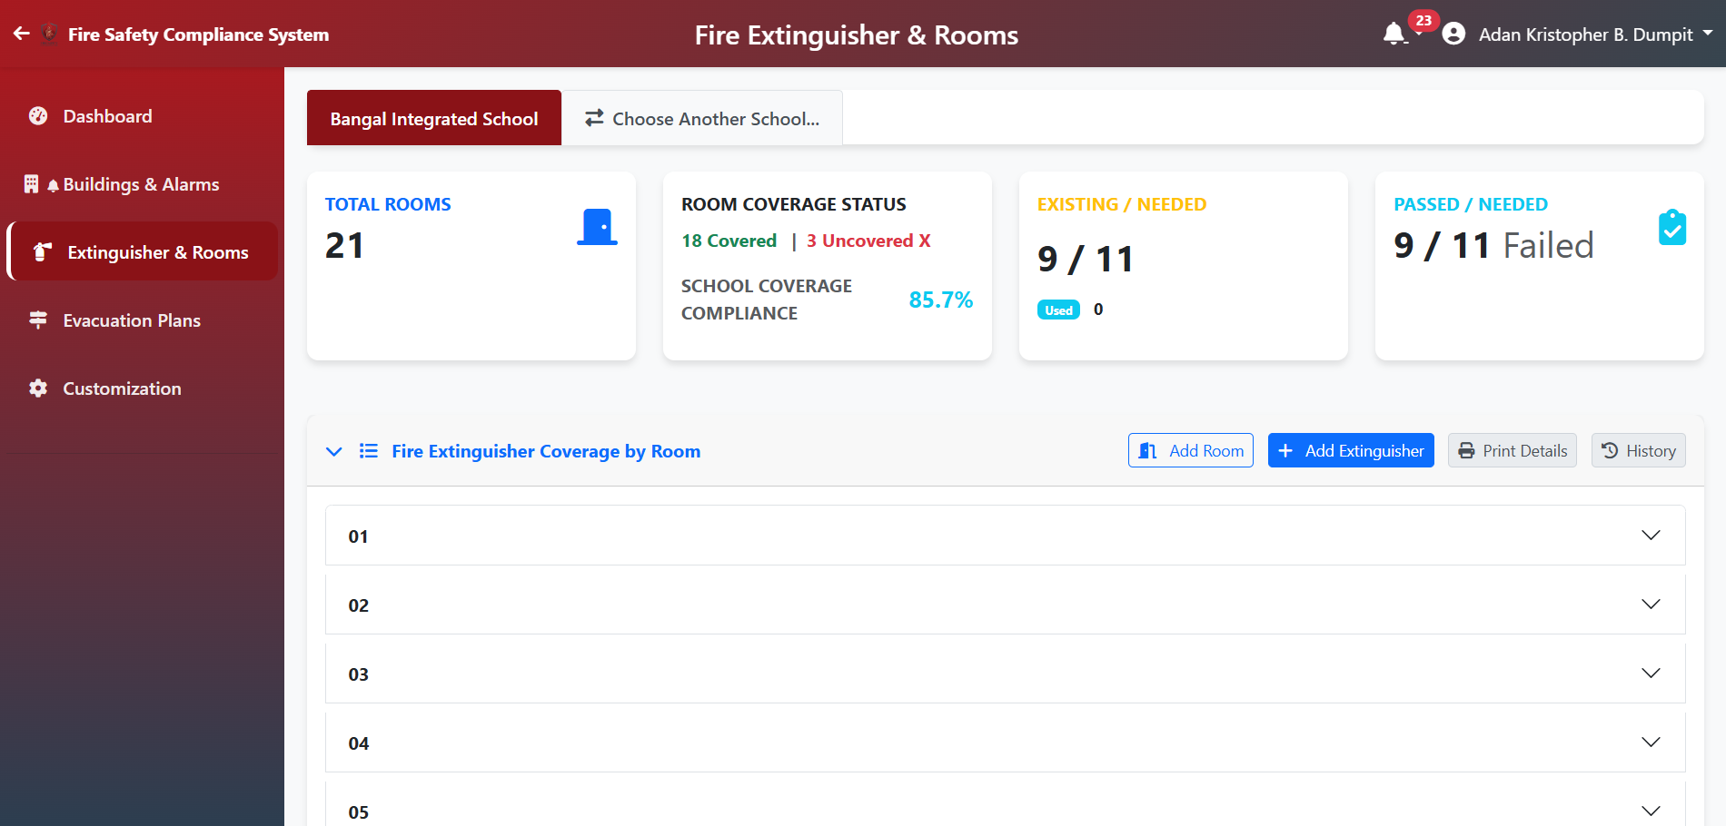
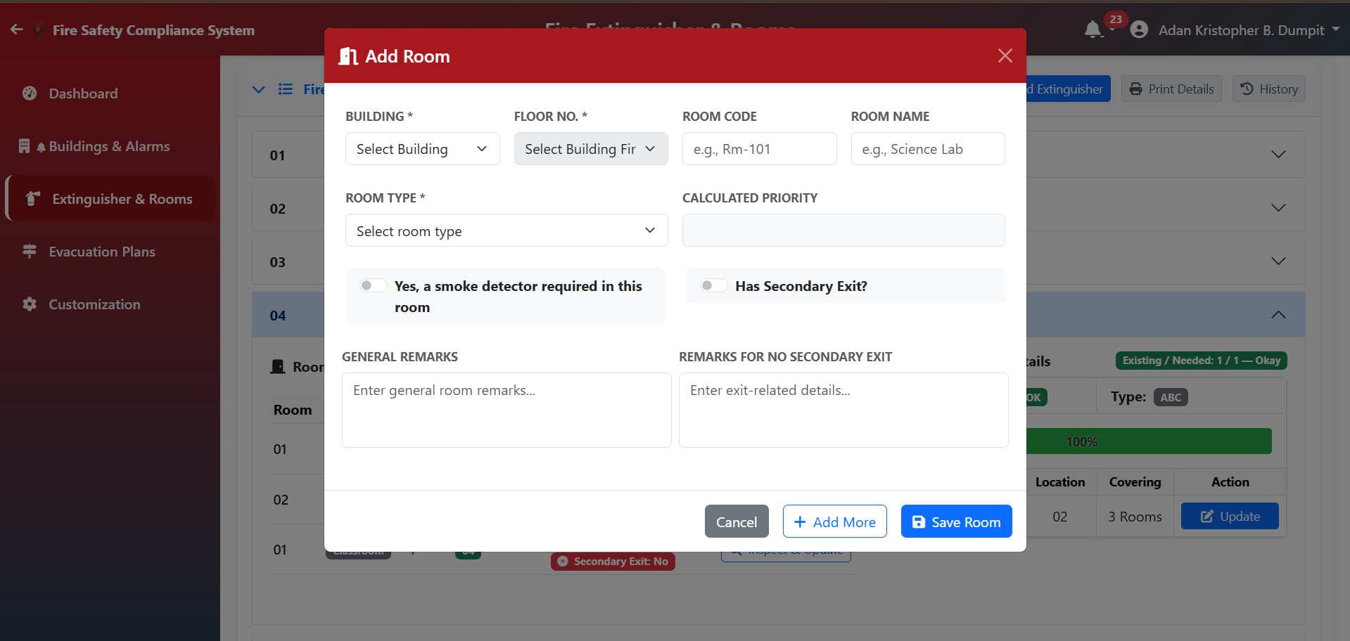
2.4 Extinguisher Page - Room Management
Ensures that every classroom and office has adequate safety coverage by mapping rooms to their respective buildings.
- Room Coverage Status: Percent of rooms with a nearby extinguisher.
- Add Room: Create a new room entry for a specific building/floor.
- Update Room: Inspect the room for secondary exits and smoke detectors.
- History Button: Access logs of previous room configurations.

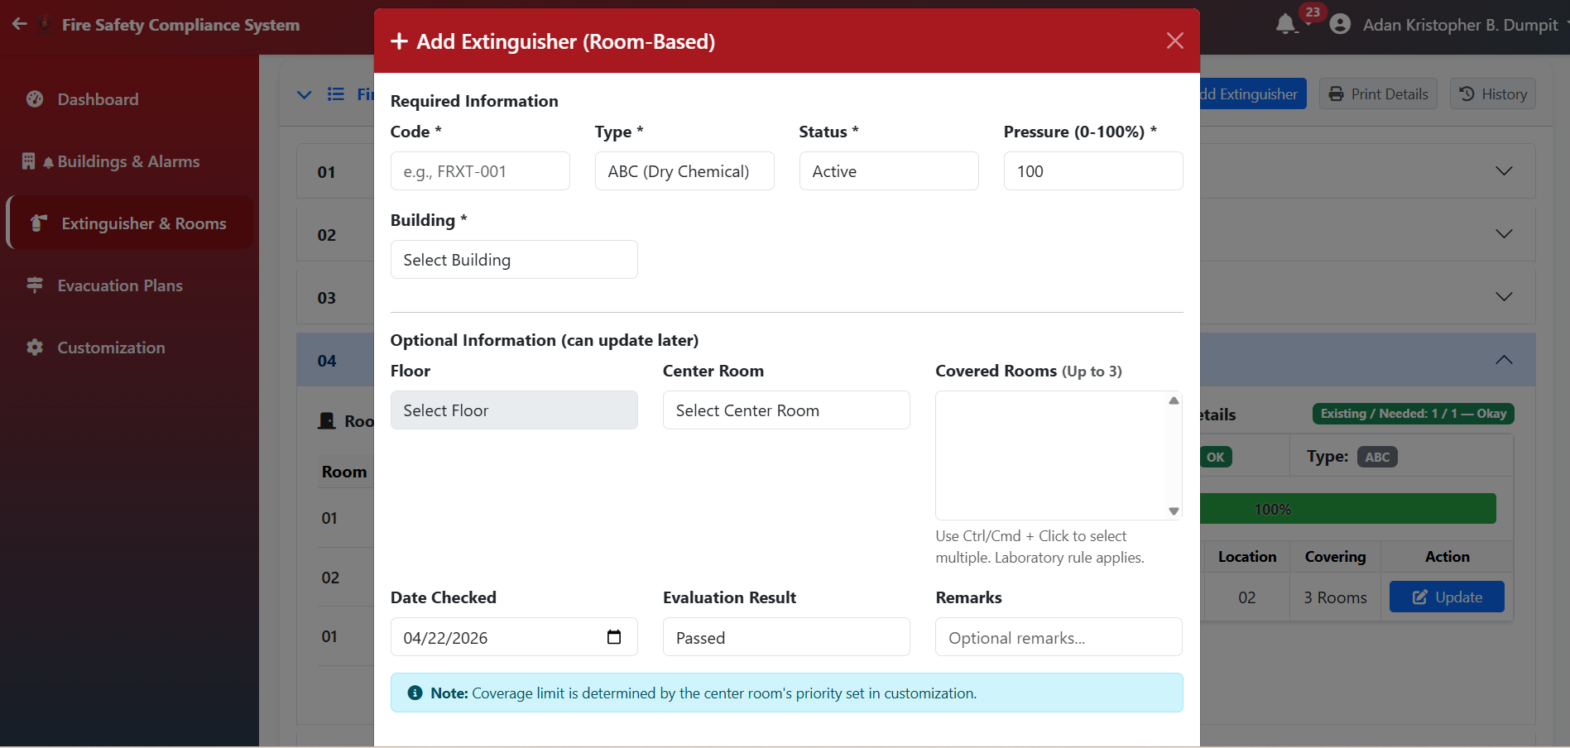
2.5 Extinguisher Page - Extinguisher Management
Monitors the inventory, location, and maintenance status of fire extinguishers to ensure immediate availability.
- Add Extinguisher Provide code, type, and its primary "Center Room", and assign for selecting up to 3 rooms covered by the unit.
- Update: Change pressure levels or status (OK, Used, Missing), & transfer and decommissioned an extinguisher there
- History Button: View all inspection logs for extinguishers.

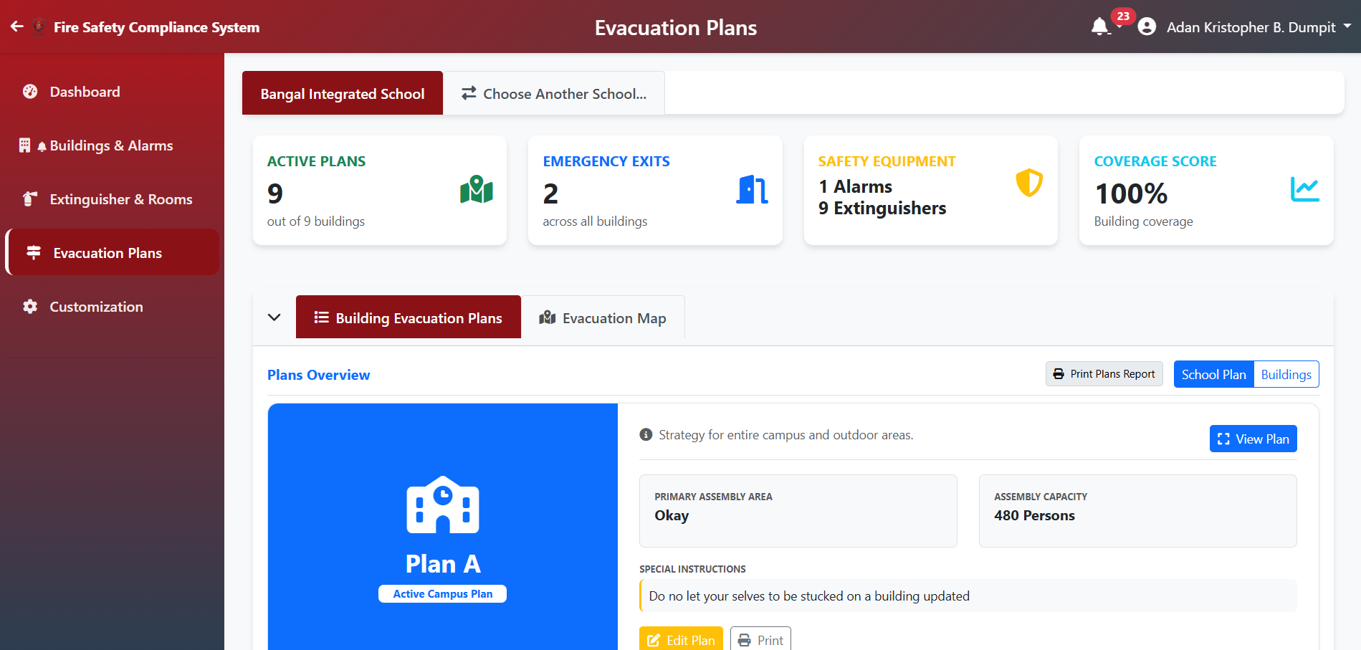
2.6 Evacuation Plan Page
Central repository for school-wide and building-specific evacuation maps and emergency protocols.
Division Cards: Shows how many buildings have uploaded plans and how many are missing.
Evacuation Plan Tab: Upload/View maps showing egress routes for each floor.

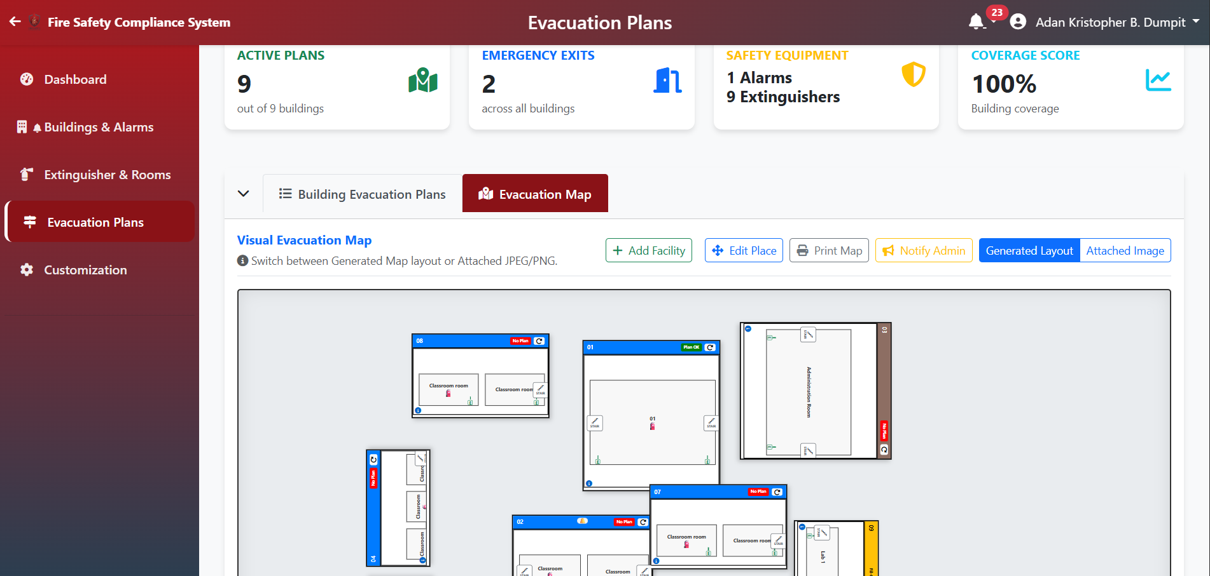
Evacuation MapTab: Manage and locate the assembly area/safe zone for the school.

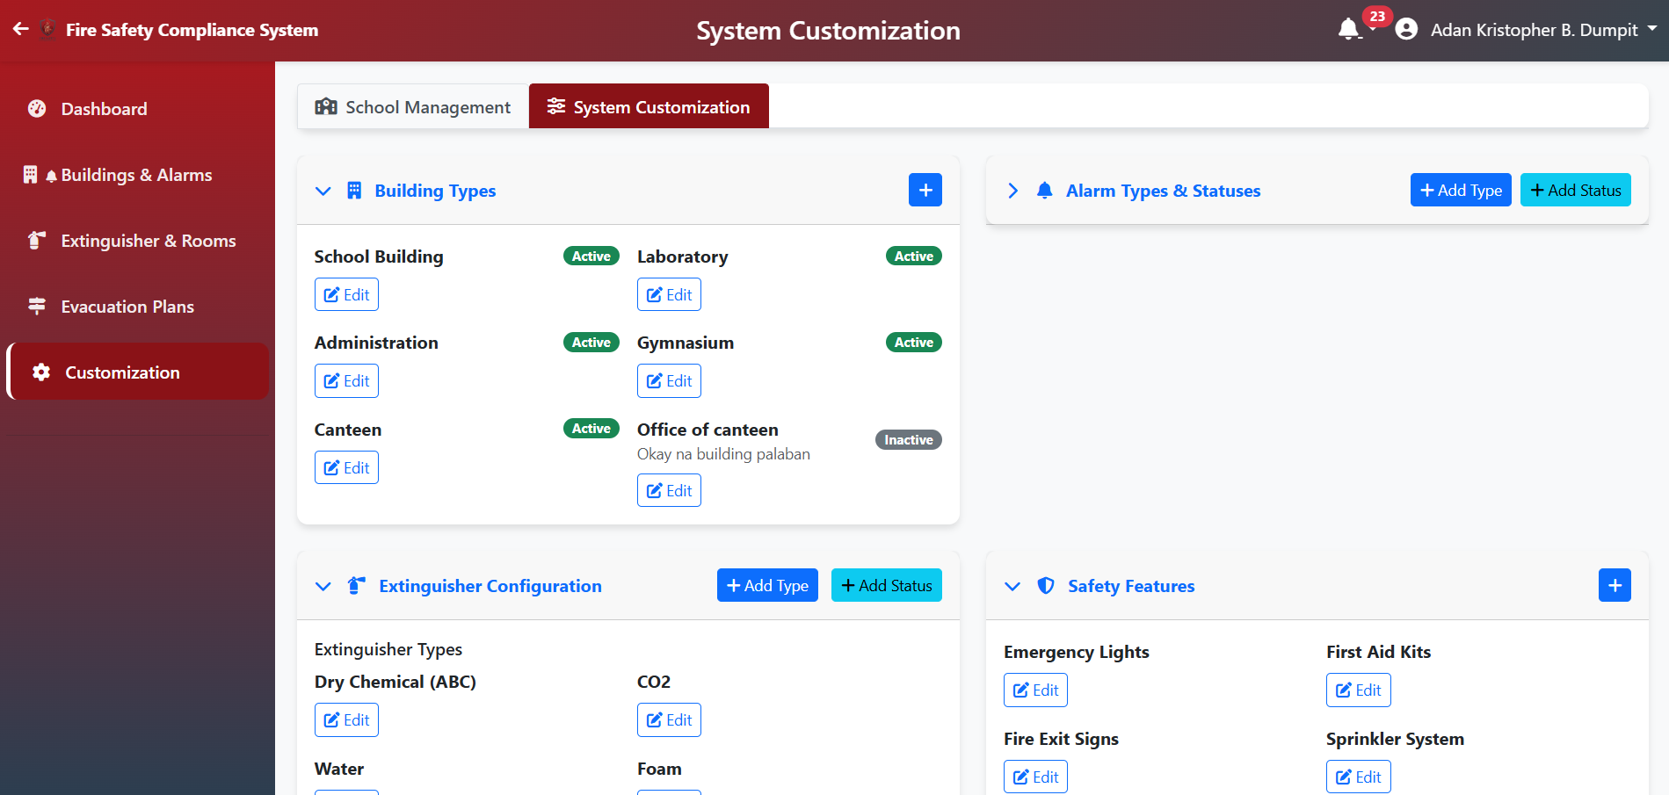
2.7 Customization Page
A management page for administrators to define system-wide parameters such as equipment types and operational statuses.
- How to Customize: Navigate to the Customization page via the sidebar or settings icon.
- Add & Edit: Use the "Add New" buttons to create new alarm types or extinguisher classifications. Click the "Edit" icon on existing items to update their labels or active status.
- Purpose: Ensures the system terminology matches the school's actual inventory and local safety standards.
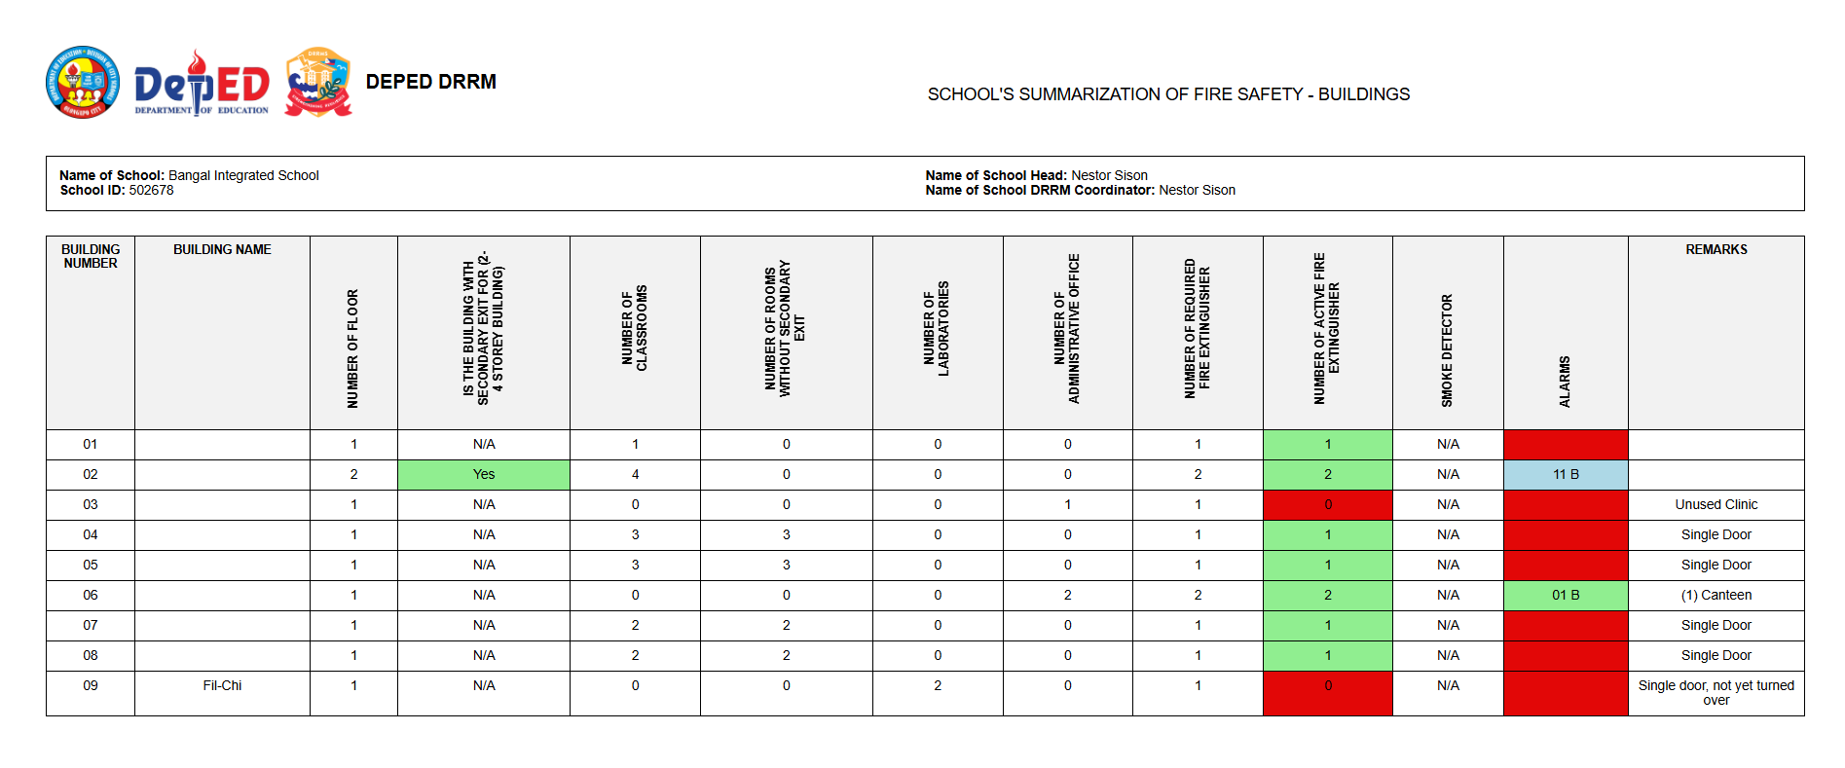
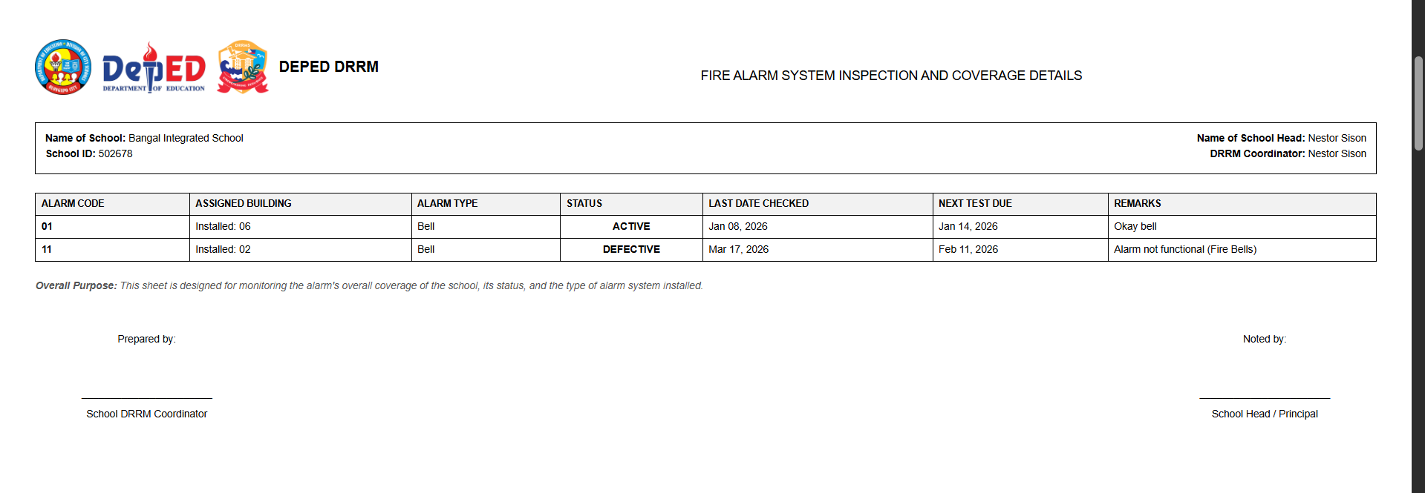
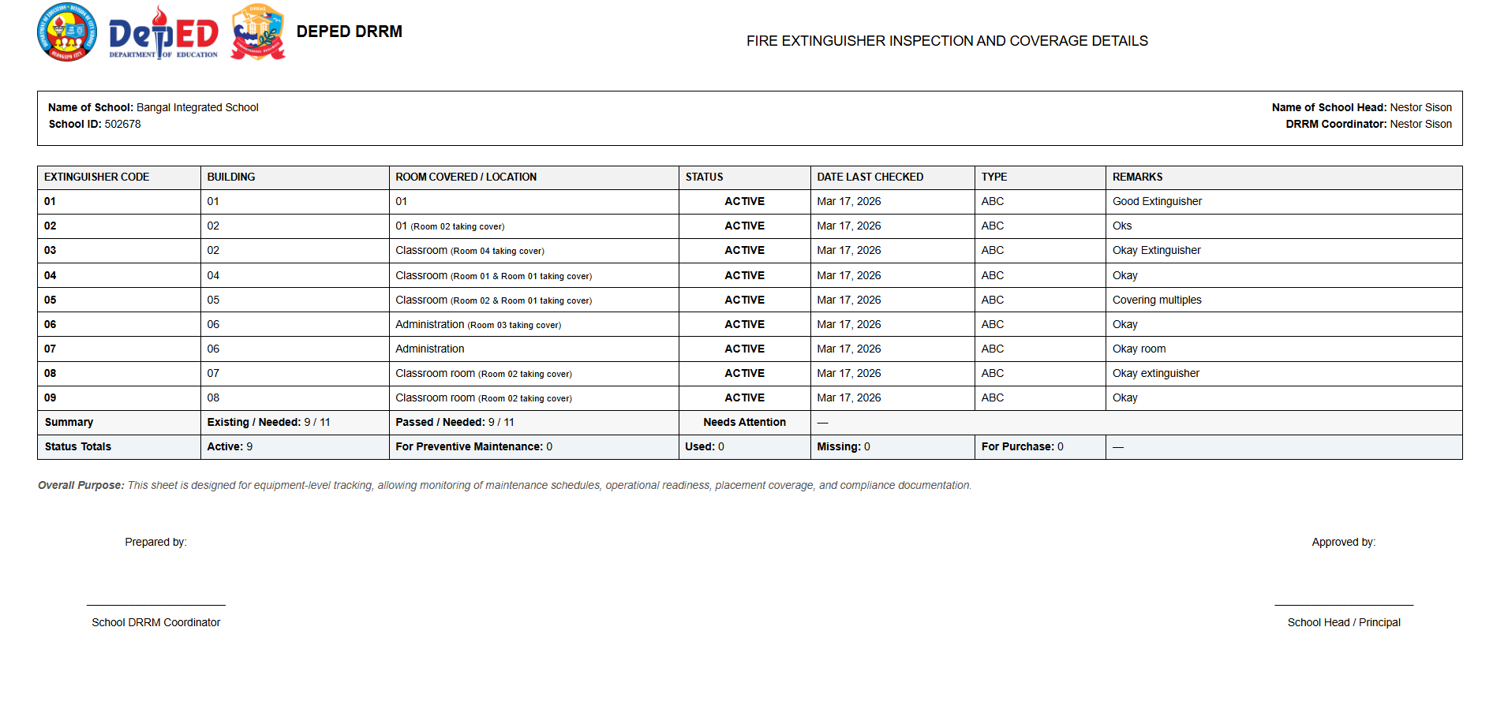
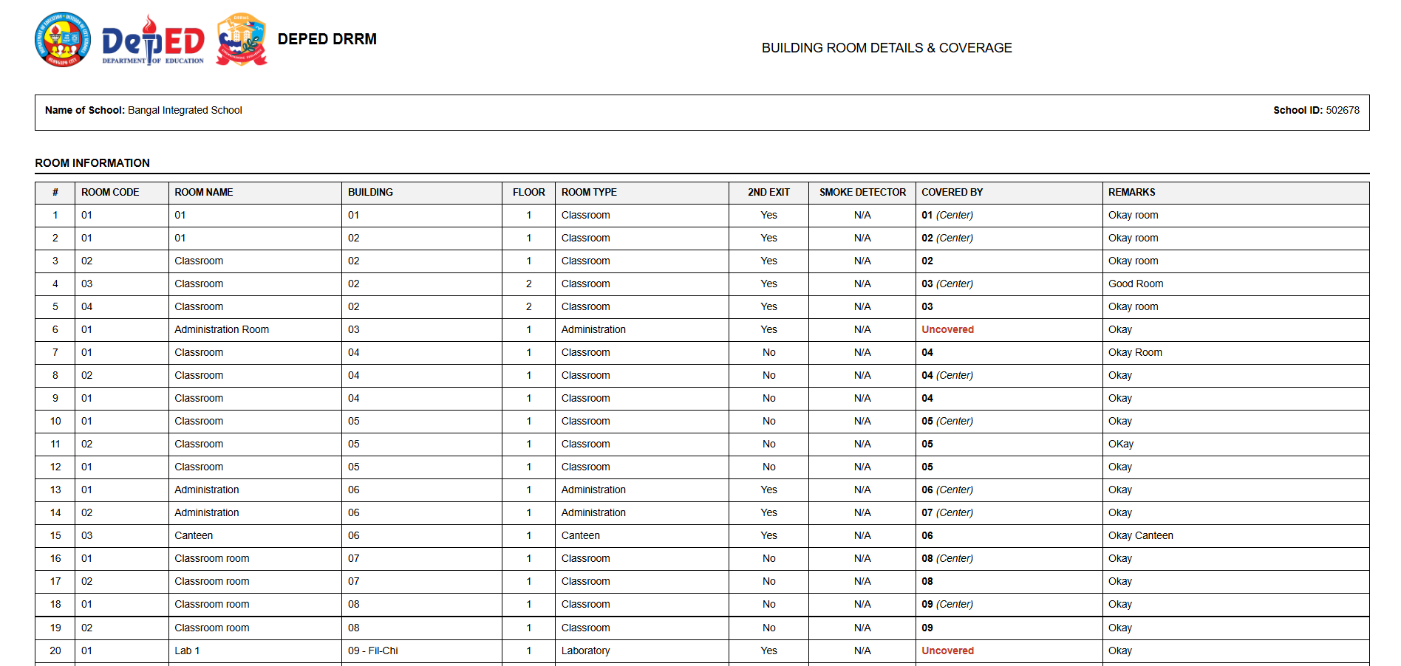
2.8 Full Fire Safety Report of the school
A comprehensive, printable summary of a school's entire fire safety infrastructure and compliance status.
- Printing Layout: Accessed via the "Full Report" button. It opens a clean, document-ready view.
What it displays:
- School Information & Profile.
- Summary of All Buildings (Floors, Rooms, Compliance).
- List of All Installed Alarms and their last test dates.
- List of All Fire Extinguishers and their pressure levels.
- Overall Compliance Rating and pending safety issues.

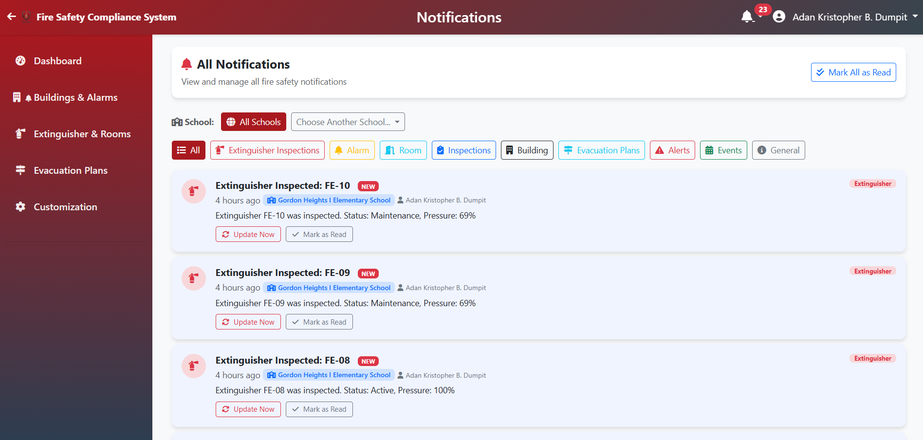
2.9 Notification Page
A dedicated hub for tracking automated safety alerts, scheduled maintenance, and administrative messages.
What it displays:
- Maintenance Alerts: Notifications for upcoming alarm tests or expired extinguishers.
- System Announcements: Messages from the division administrator.
- Activity Updates: Logs of recent room inspections or building updates.
Usage: Use the "Mark as Read" feature to manage your task list and ensure no safety deadline is missed.
3. Typhoon/Flood Monitoring System
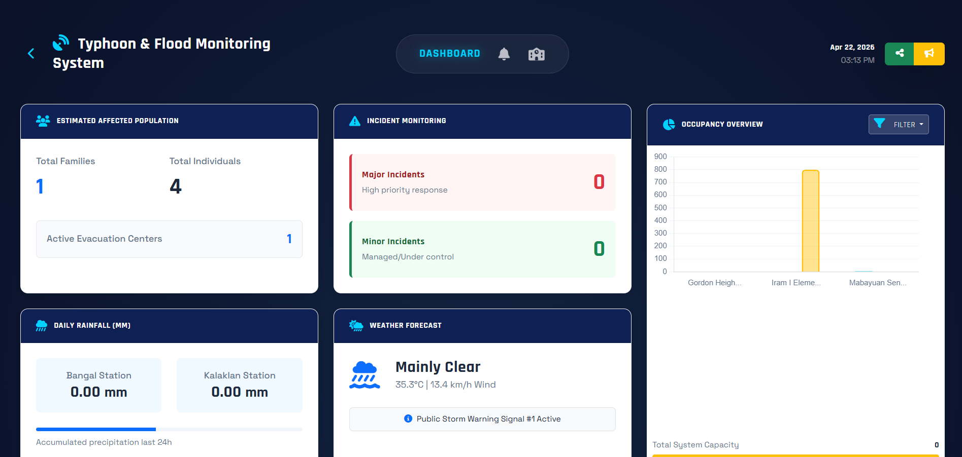
3.1 Dashboard
A real-time monitoring screen for weather alerts and the active status of evacuation centers during disasters. It displays current weather alerts, active monitoring status, and active typhoon tracks.
Buttons:
- Add Center: Opens modal to register a new Evacuation Center.
- Active Centers: Filter to see only currently occupied sites.
- Status Indicators: Red (Extreme Warning), Yellow (Watch), Blue (Normal).

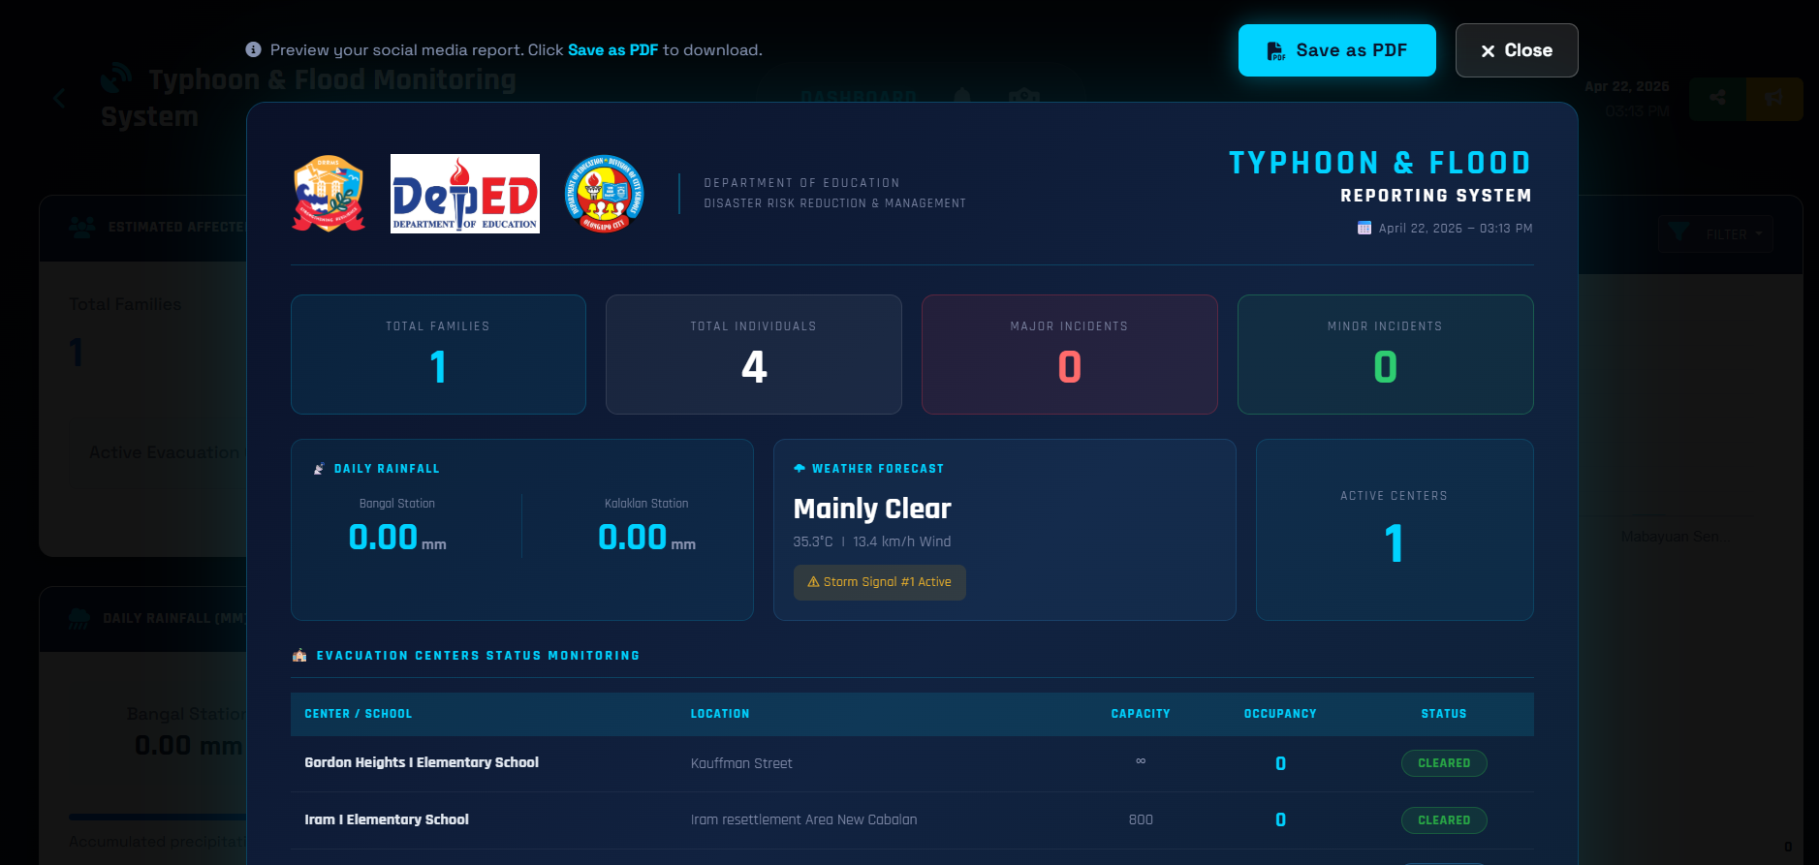
3.2 Report Posting
Facilitates the generation of official monitoring reports for submission to local government or education authorities.
- Generate and save monitoring reports as PDF.
- Click "Generate PDF" or the "Print" icon to create a formal document of the current status.

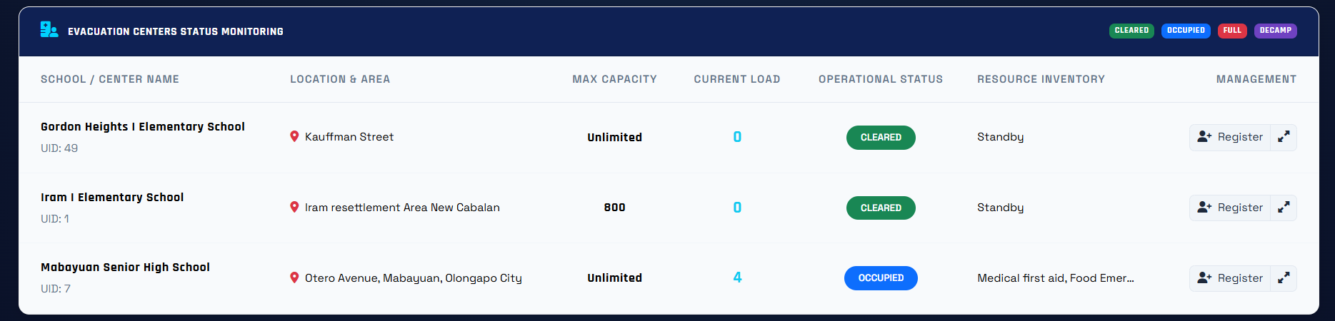
3.3 Dashboard - Evacuation Center & Registry Family
Manages the registration and allocation of evacuees to safe zones during emergency situations.

- Evacuation Center division: Shows current occupancy, capacity, and status (Operating/Standby).
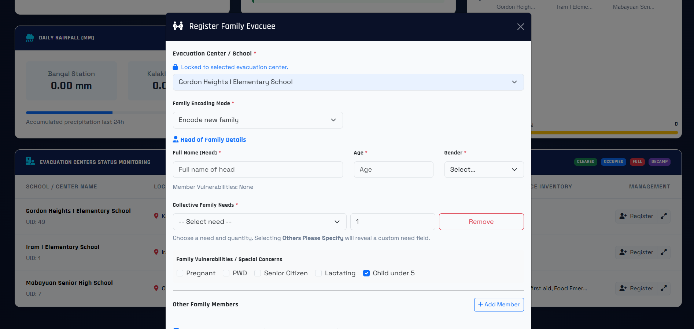
- Registry Family: Fill in Head of Family, No. of Members, and specific needs (Pillows, Blankets, Food, etc.). Can also select an existing school/center for assignment.

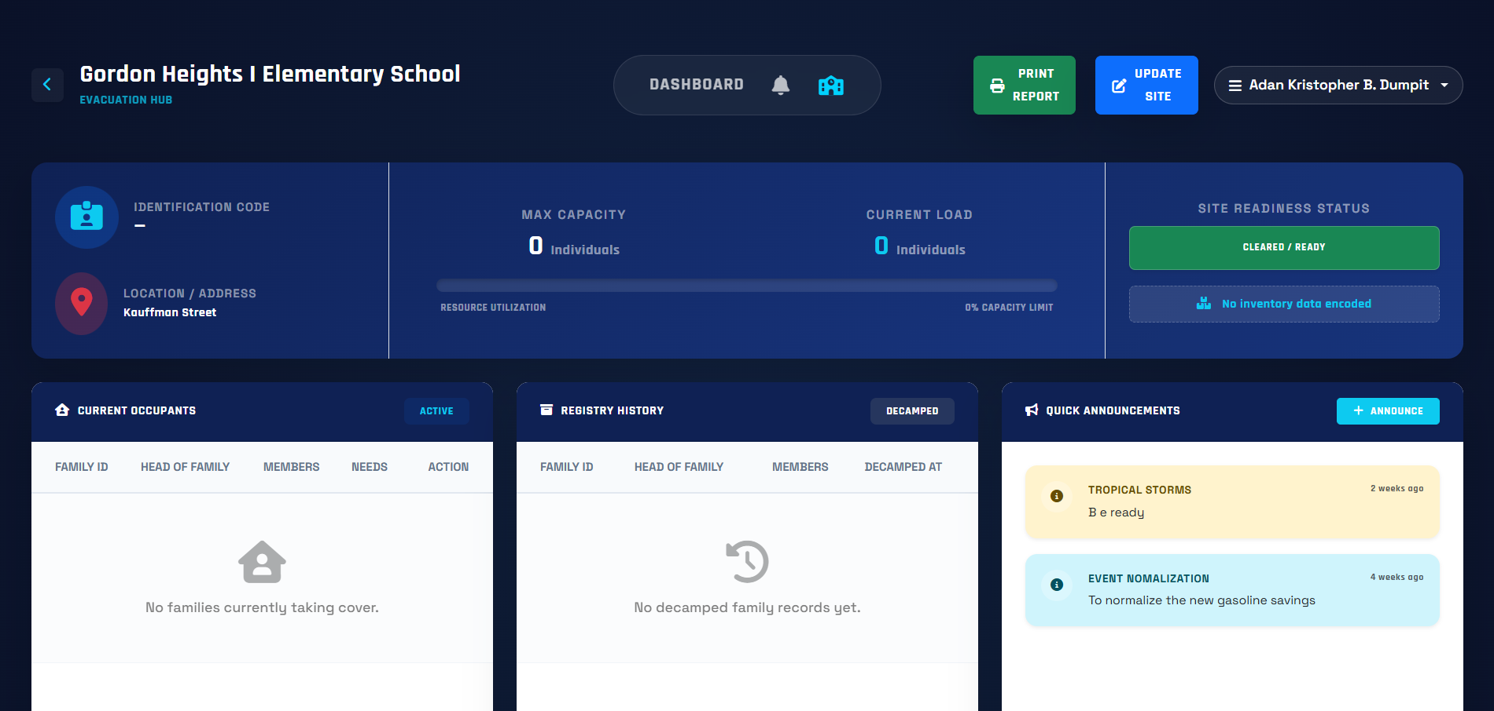
3.4 Evacuation Center Page
A detailed view of a specific evacuation site, including family demographics and supply needs.
- Displays: Breakdown of families, member counts, and specific needs inventory.
Buttons:
- Add Needs: Request/Update supplies for families.
- Transfer Family: Move family to a different center if needed.
- Evacuate Family: Robert’s family has returned home safely.

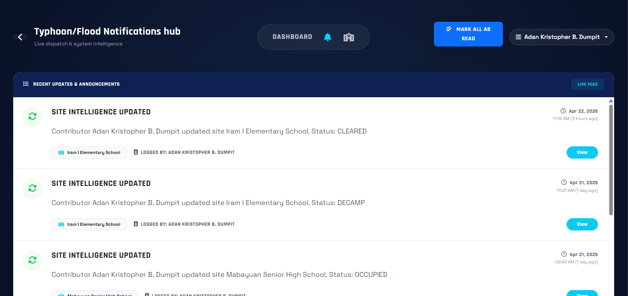
3.5 Notification Page
A history of weather advisories and administrative alerts related to disaster monitoring.
- Displays system-wide weather alerts and manual announcements from administrators.

4. Incident Checklist System
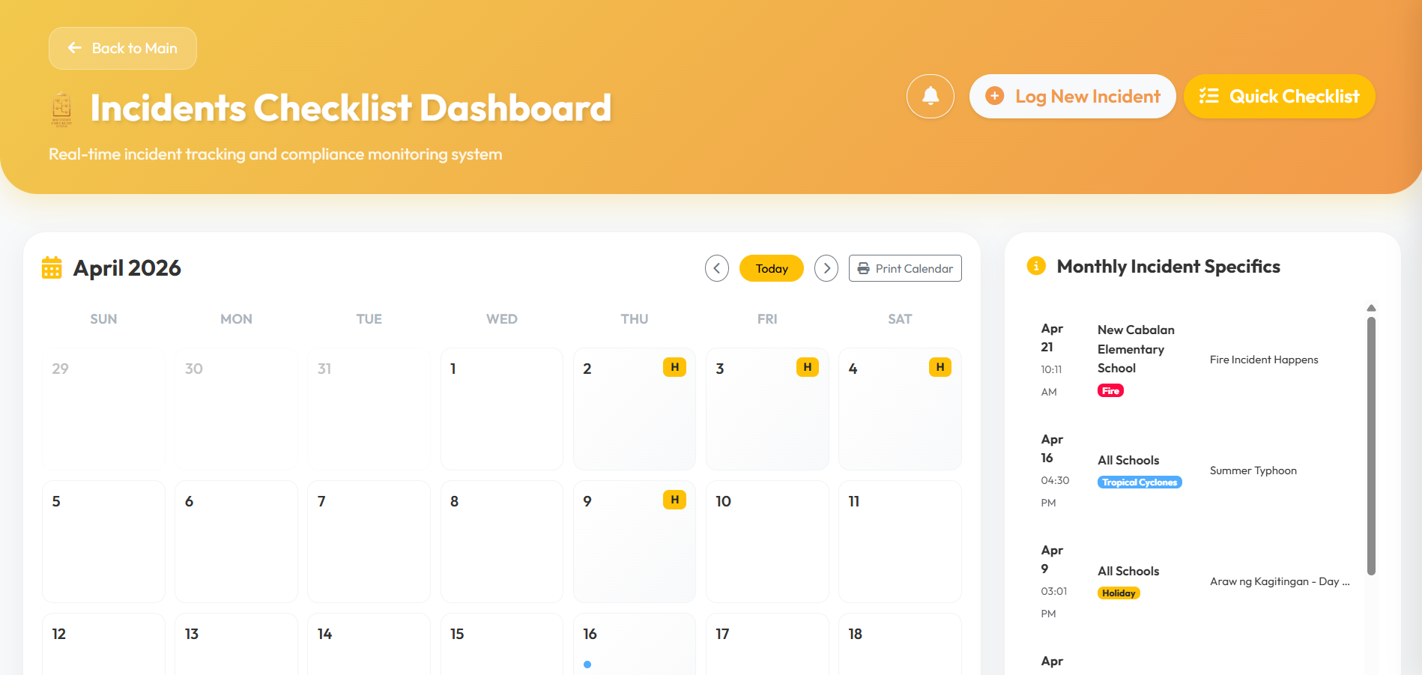
4.1 Dashboard - Administrator
The main control panel for logging and tracking campus incidents and compliance events on a global calendar.
- Log Incident - Select "Incident" tab to record date, type (e.g., Flood, Fire), and affected school.
- Log Compliance - Select “”Compliance/Event” tab to log a Cancelled class, school event etc. for the school
- Calendar - Interactive view of all logged events. Click any date to view or add details.
- Legend Filters Toggle view for specific types (Rainfall, Landslide, Accident, etc.).
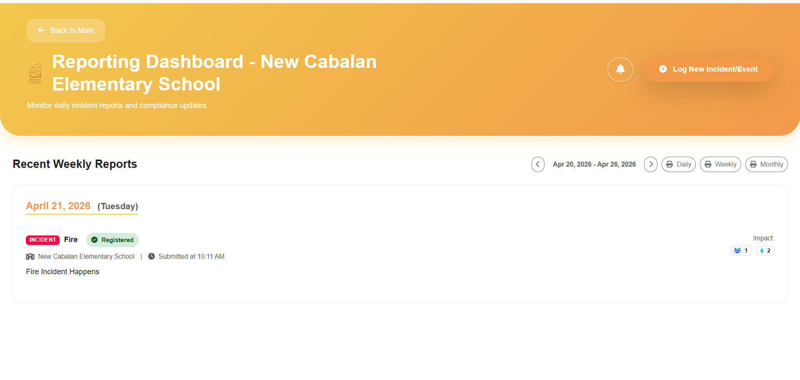

4.2 Dashboard - Contributor
A specialized reporting interface for school-level staff to submit daily logs and incident reports.
- Difference Restricted to viewing and reporting for their assigned school only. To use to submit daily incident/compliance reports for approval.
Buttons
- Pending Review: Shows reports waiting for Admin approval.
- Registered: Confirmed reports appearing on the calendar.
- Rejected: Reports sent back with a reason for correction.

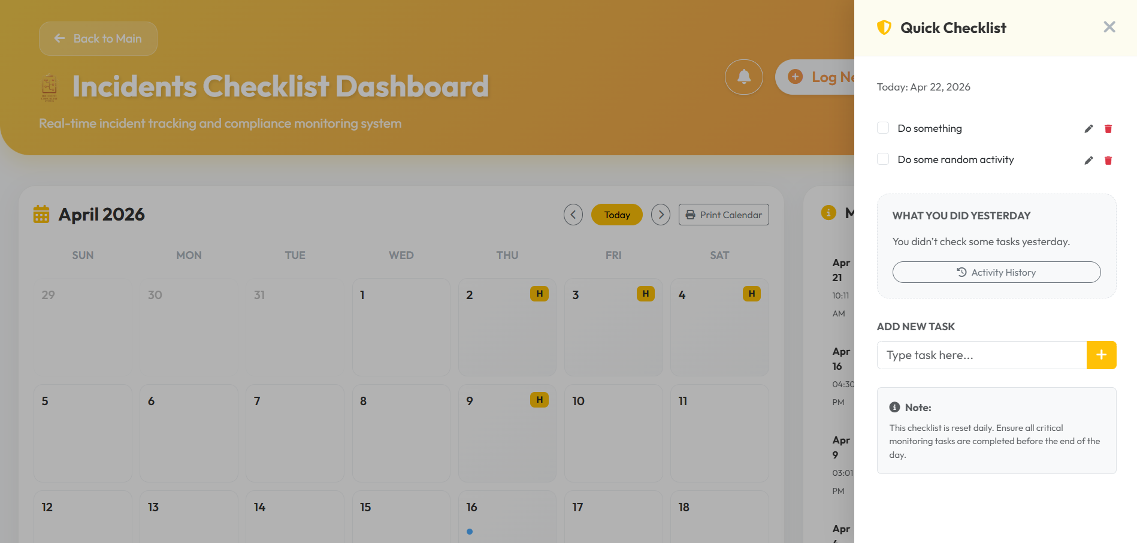
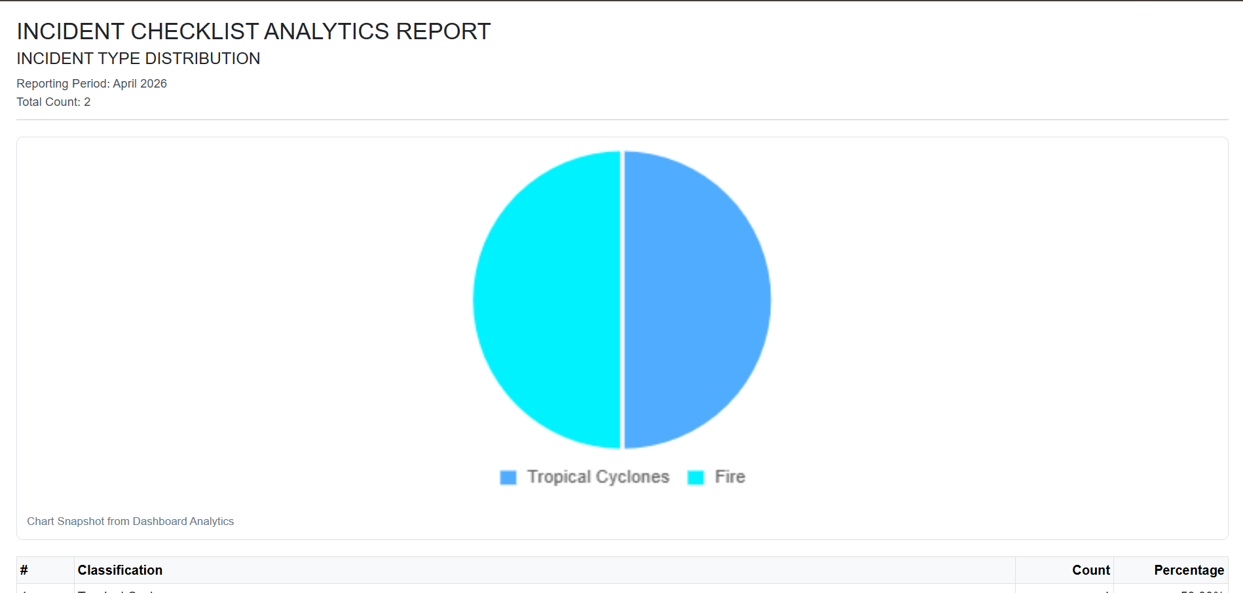
4.3 Quick Checklist & Data Chart
Visual analytics and task management tools to help users track progress and export safety data for reporting.

- Printing Click "Print Analytics" or the "Print" icon on charts to export pie/column data.
- Calendar Printing Use "Print Calendar" to get a hard copy of the monthly log.
- Quick Checklist Sidebar for tracking daily safety tasks; click items to mark as done.

5. COMPREHENSIVE SCHOOL SAFETY SYSTEM
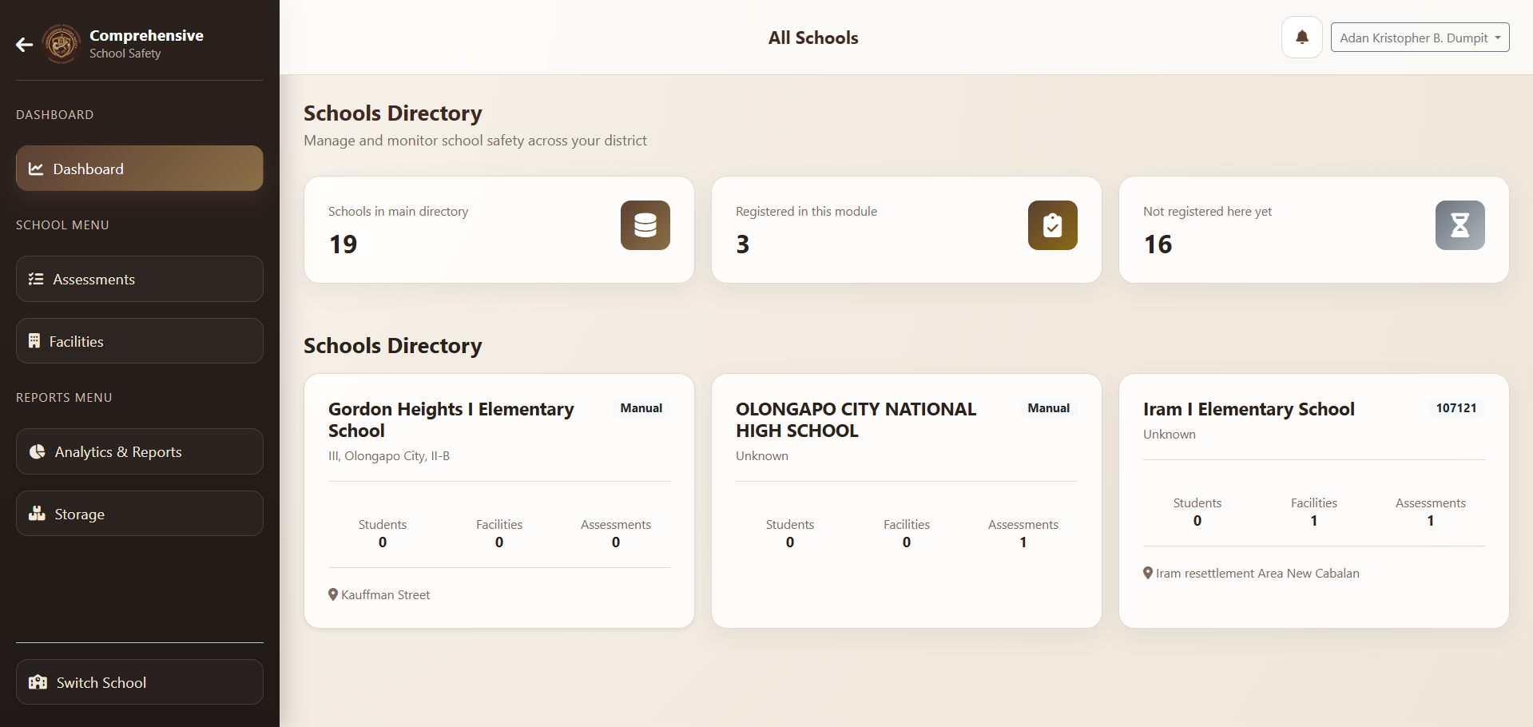
5.1 Dashboard
A snapshot of Comprehensive School Safety metrics, focusing on student totals and facility conditions.
- KPI CARDS: Real-time count of Assessments Completed, Total Students, and Facilities.
- School Info Displays basic demographic and contact data for the active school.

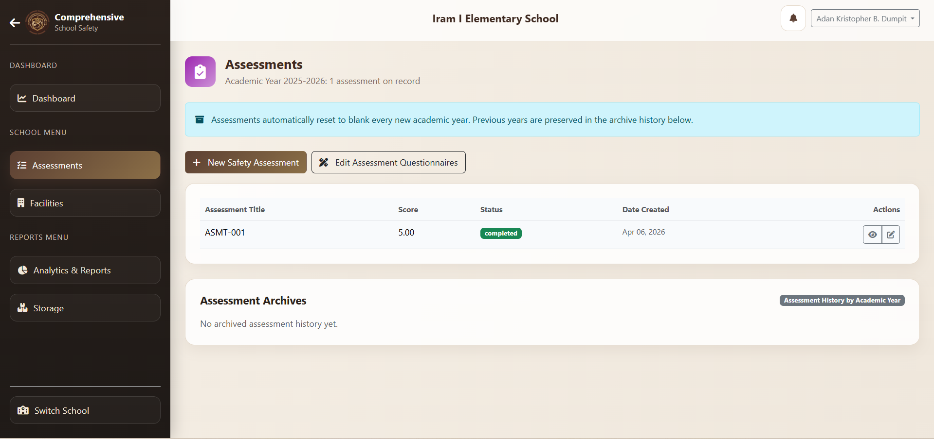
5.2 Assessment Page
An interactive checklist based on national safety pillars to evaluate a school's overall disaster readiness.
How to Assess:
- Click "Start New Assessment".
- Fill in General Info (Assessor, Date).
- Navigate through Pillars using the sticky menu.
- Rate items (Yes/No), assign Points, and add Remarks.
Buttons:
- Pillar Links: Instant jump to specific checklist sections.

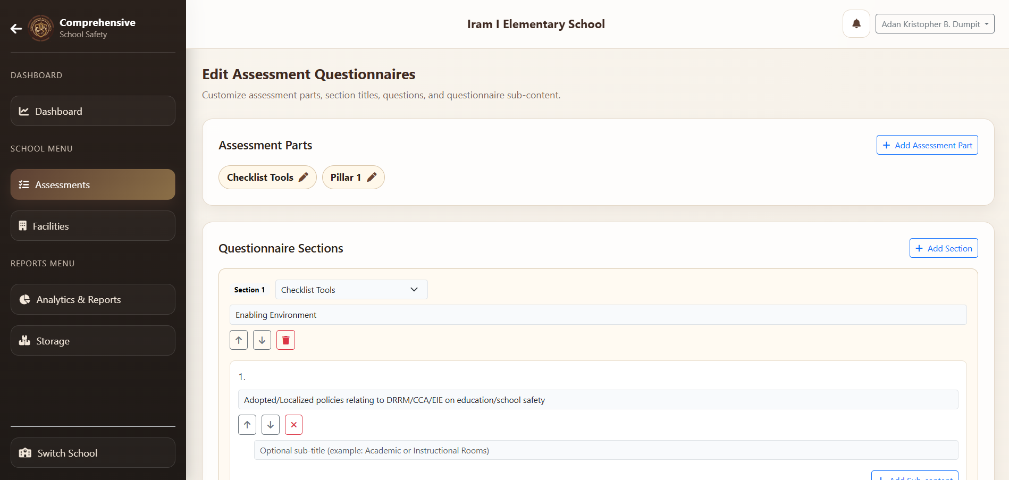
5.3 Edit Assessment Page
Allows assessors to refine previous evaluations as school conditions change or improvements are made.
- Click "Edit" on a completed assessment to update ratings or remarks.
- Totals are automatically recalculated upon saving.

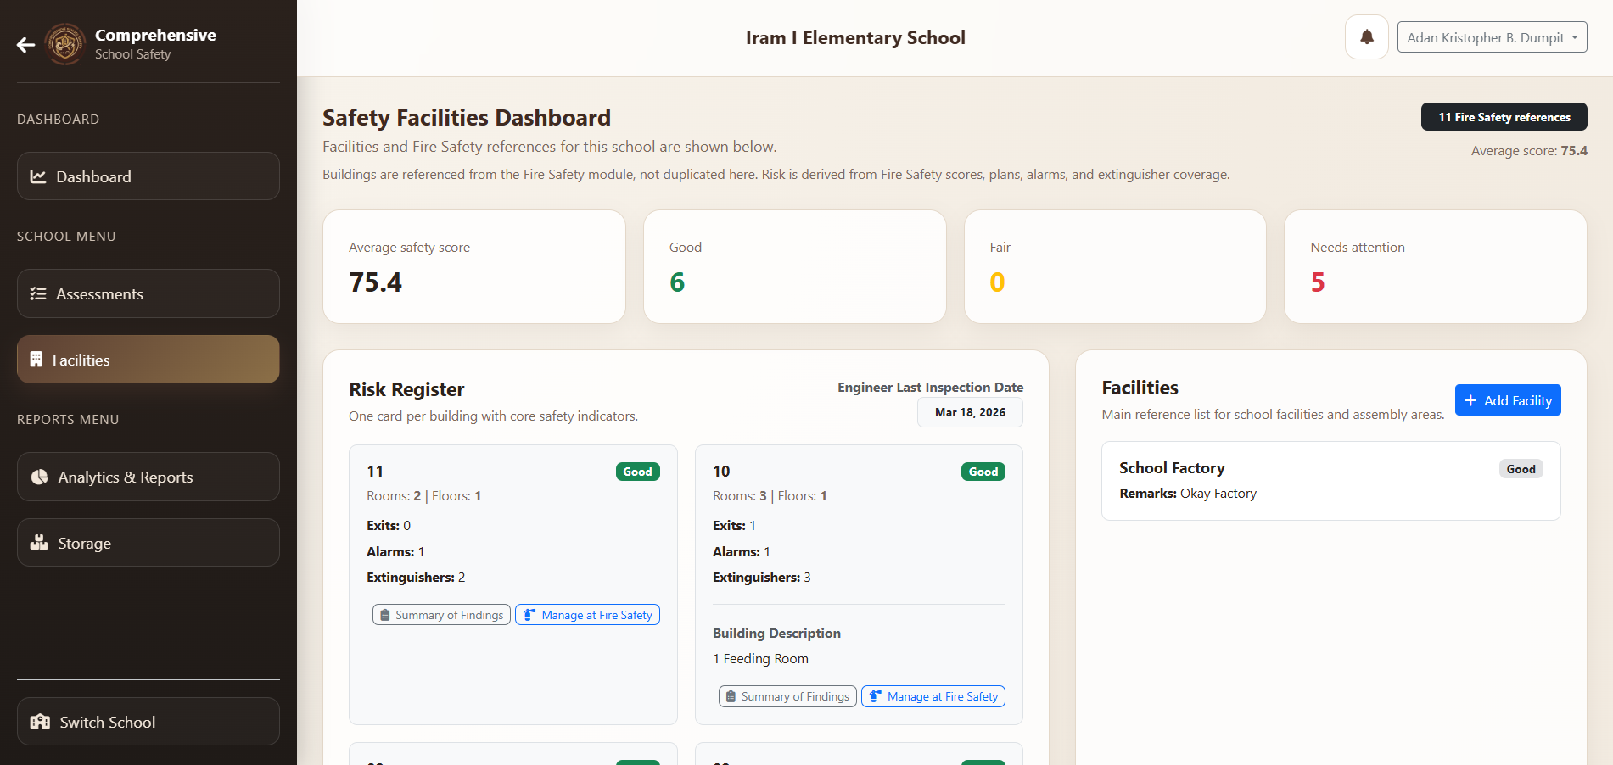
5.4 Facility Page
Integrates physical facility data with safety findings to create a comprehensive risk register.
How to Use: Register assembly areas and generic school structures.
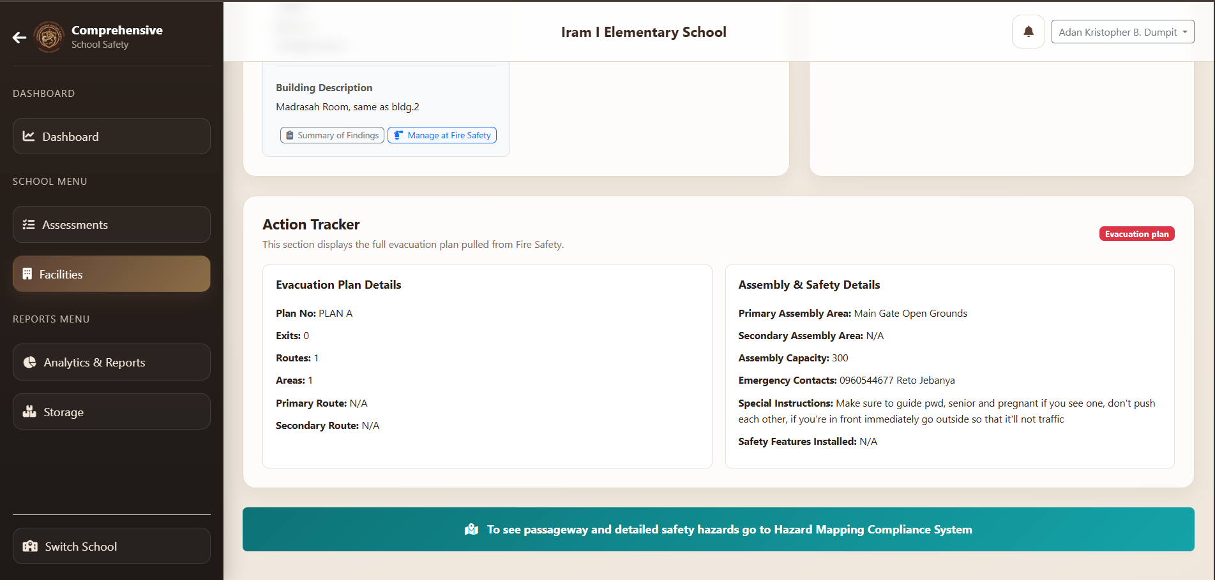
Data Displayed:
- Risk Register: Summary of safety indicators pulled from Fire Safety buildings.
- Evacuation Plan: The school-wide protocol for emergencies.

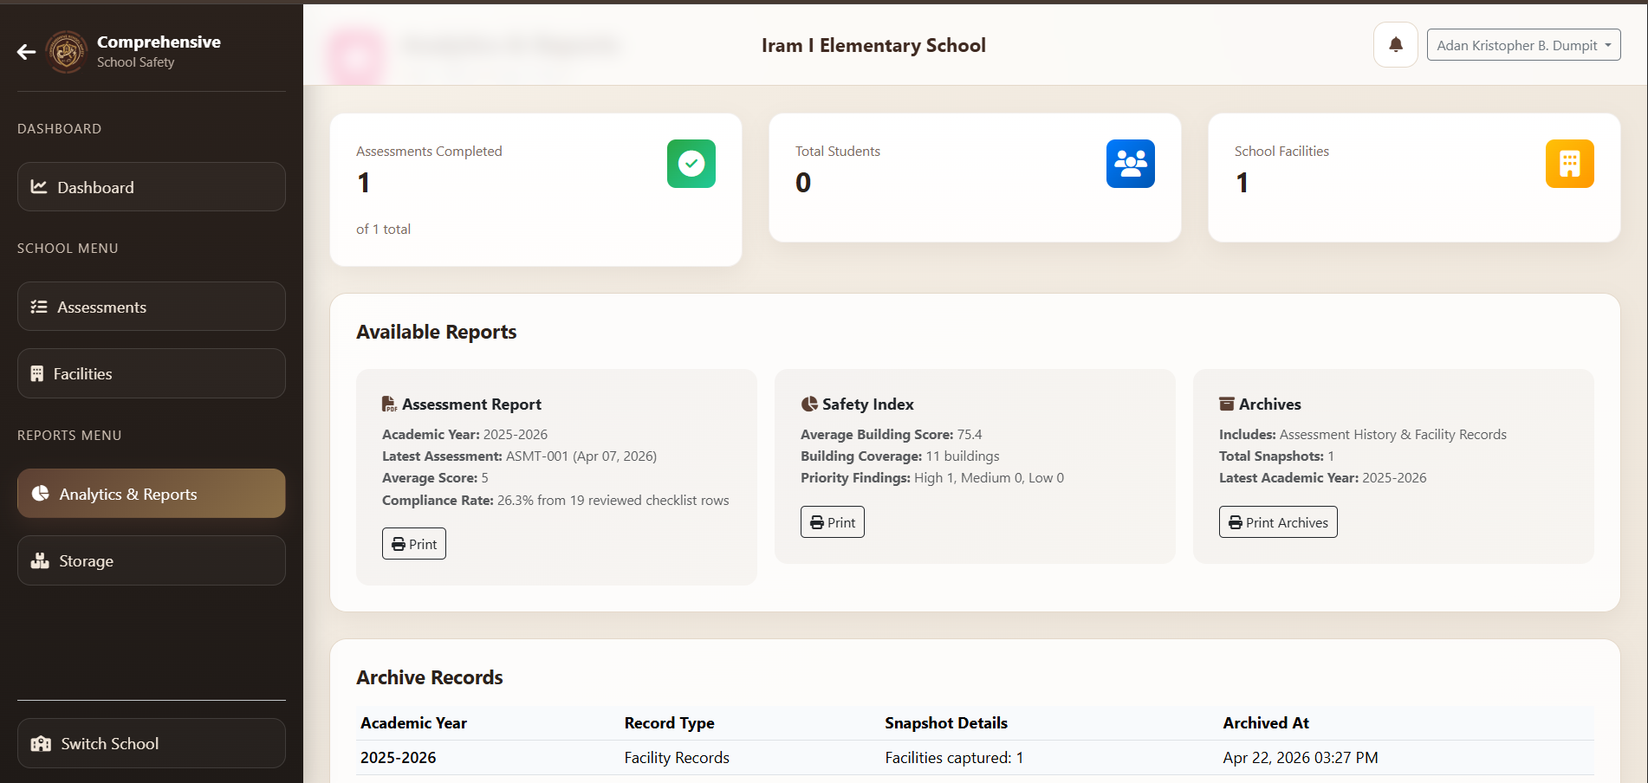
5.5 Analytics & Reports page
Compiles assessment data into actionable summaries and historical archives for long-term planning.
Data Reported: Compliance rates, average safety scores, and student/facility totals.

Buttons:
- Print Assessment: Detailed questionnaire report for a specific date.
- Print Safety Index: Scorecard overview for all school buildings.
- Print Archives: Historical timeline of safety assessments.

5.6 Printing Layout
Standardized templates for generating high-quality physical copies of assessments and safety scorecards.
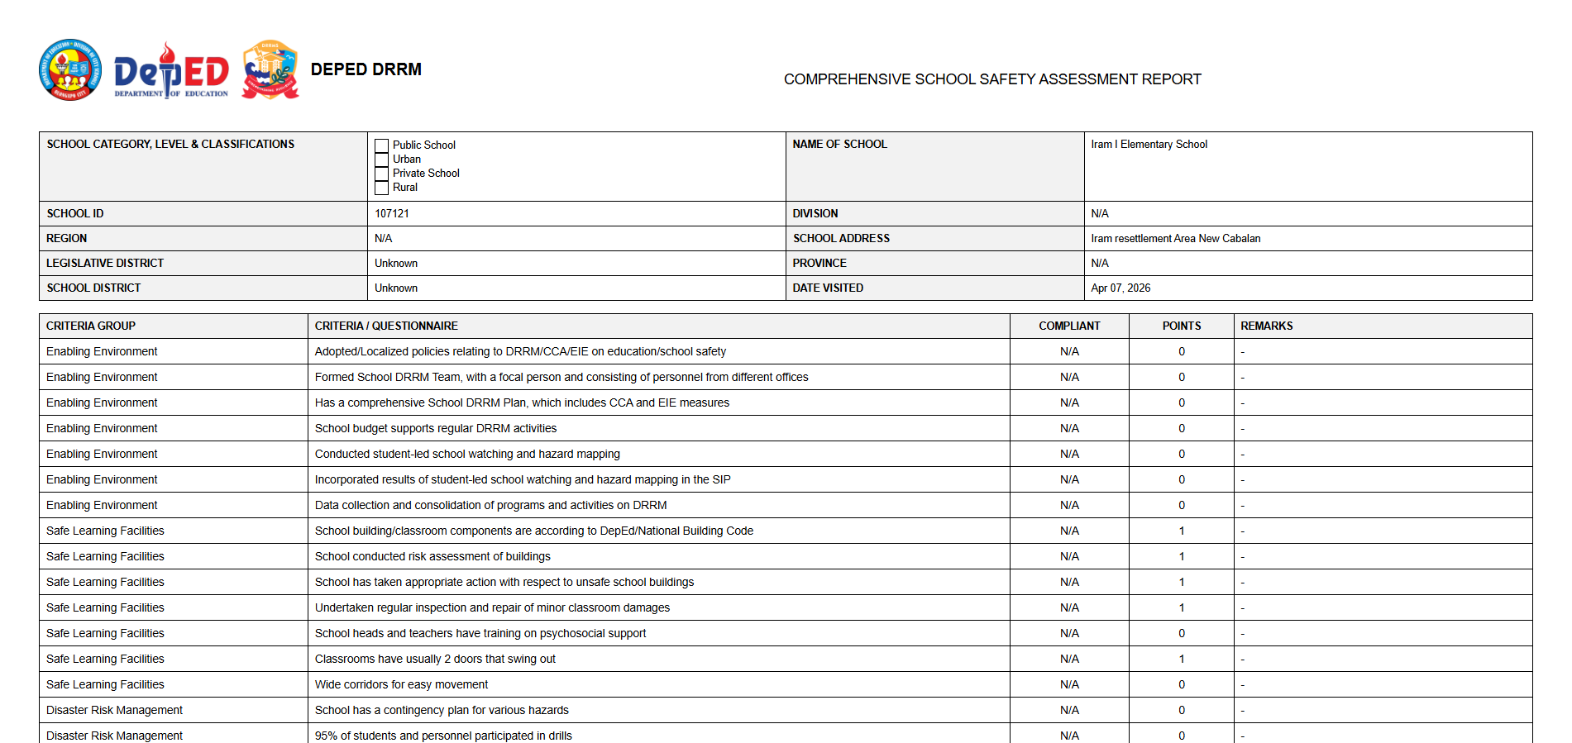
- Assessment - High-resolution table of all checklist criteria and responses.
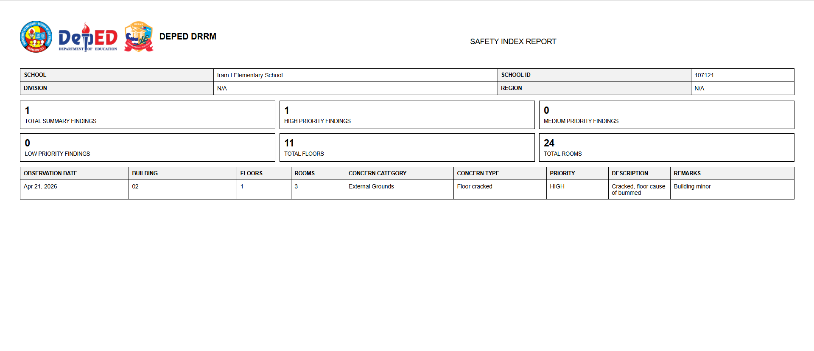
- Safety Index - Visual summary of building conditions and priority findings.
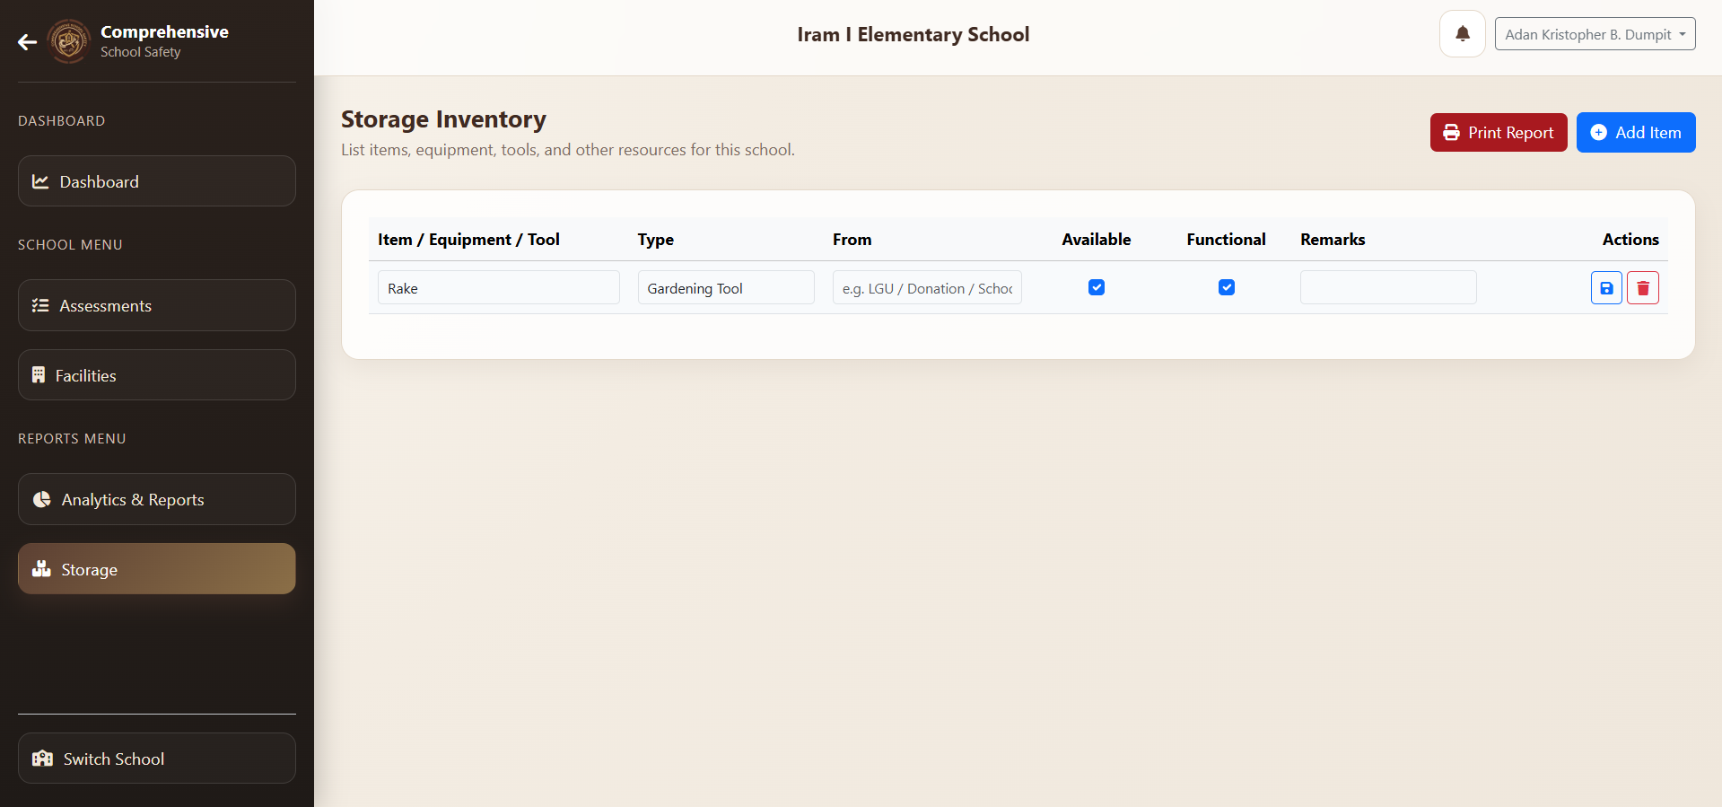
5.7 Storage
An inventory management system for emergency supplies, medical kits, and rescue equipment.
- How to use: Manage the inventory of emergency equipment (tools, medicine, supplies).
- Item Concerns: Track if items are Functional, Available, and where they were sourced from.
- Print Report: Official inventory list for physical audits.

6. Hazard Mapping
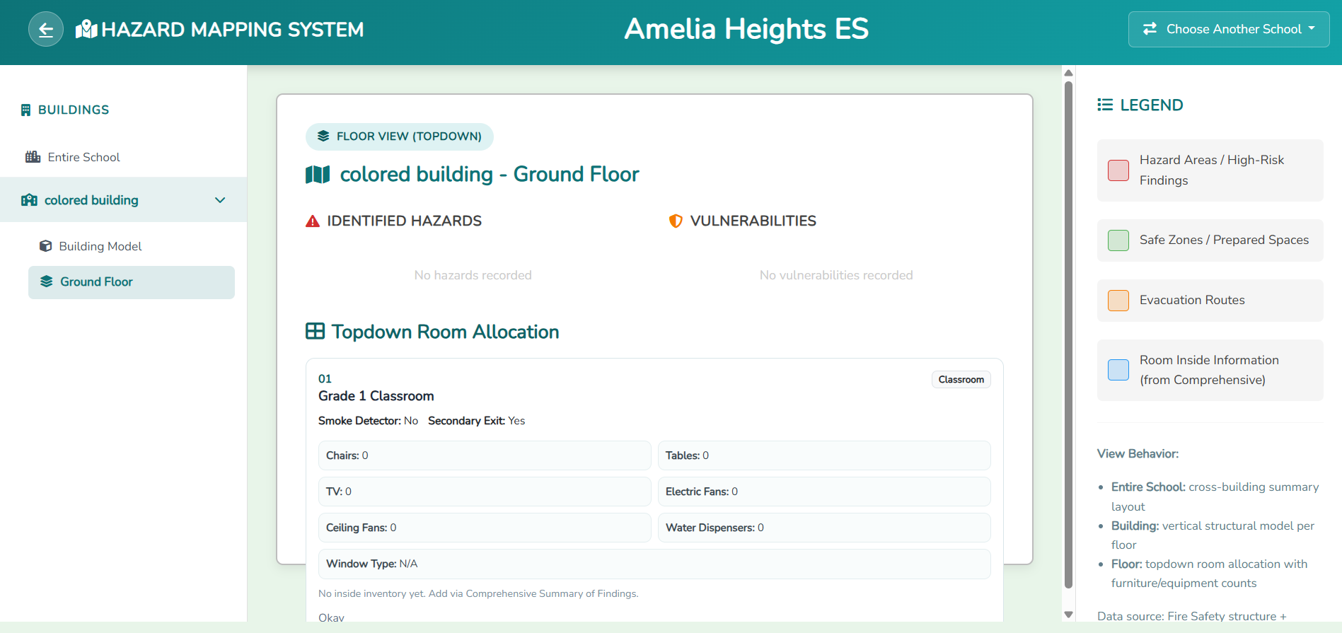
6.1 Dashboard
A visual mapping tool that provides multi-dimensional views of hazards and structural data across the school grounds.
Map Navigation
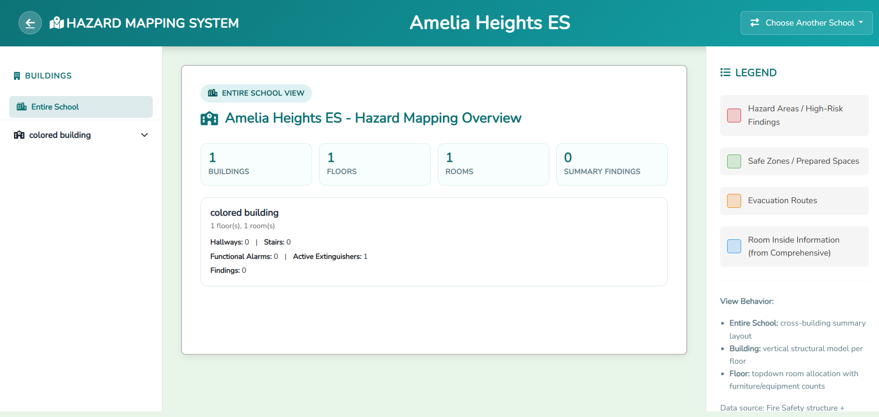
- Entire School - View overall stats and building-level safety features.
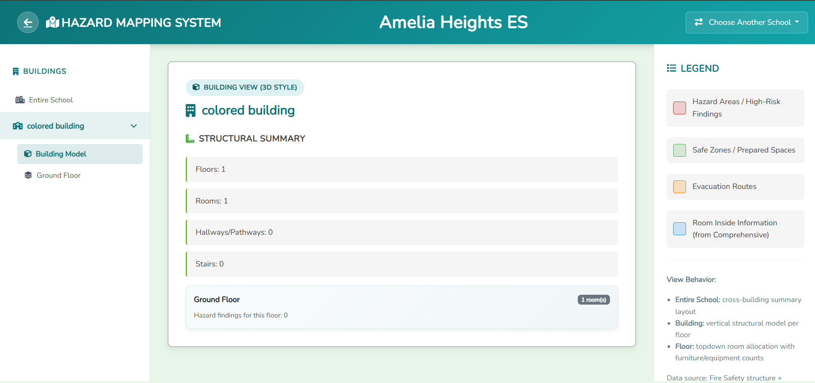
- Building Model - View a vertical stack of floors and find counts.
- Floor View - Topdown layout of rooms, hallways, and stairs.
Primary Concerns
- Hazards/Vulnerabilities: Identifying high-risk areas per floor.
- Room Allocation: Viewing specific inventory (chairs, tables, TV) inside each room.

